

##### MODULE 1: SCOPE AND RATIONALE

##### (HM/HR/ADMIN)

Module 1: Scope and Rationale (HM/HR/ADMIN)

# Welcome

## Purpose of this Training

This course is a high-level overview of the Job Announcement Express, or JAX module and its features, and instruction on how you will use the JAX module to create job announcements for your open positions.

## Length of Training

This course is approximately 3 hours n length, and is comprised of classroom instruction, exercises that you will work through either individually or in small groups, and scheduled breaks.

## Who should take this Training

This training is appropriate for anyone who is new to the JAX module, and who is responsible for creating job announcements for the US Fish & Wildlife Service.

## Agenda:

This is a 3-hour long course, and should approximately follow the below schedule:

Module 1 (Scope and Rationale): 5 minutes  
Module 2 (Getting Started in HCMS): 35 minutes  
Module 3 (Create a Job Announcement): 65 minutes  
Module 4 (HR Functions within JAX): 15 minutes

Module 5 (Admin Functions within JAX): 20 minutes

# Overview of the Training

## What you’ll be able to do when you complete the training

When you have completed this course, you should be able to login to the JAX module, create a new job announcement (either brand new or from an existing job announcement), and then work through the required steps to submit the job announcement (generated in the JAX module) for review, approval, and final export to USA Staffing.

## Overview of each Module (e.g. what is covered in each)

### Module 1: Scope and Rationale

This module provides information on the training objectives, what users should be able to do when they have completed the training, how long the training takes, and how to use the provided course materials.

### Module 2: Getting Started in HCMS

This module provides background information on how the Human Capital Management System, or HCMS, links both the PD Express and JAX modules together, and how JAX interfaces with USA Staffing. You’ll also learn how to access JAX via HCMS, and explore the JAX menu options in this module.

### Module 3: Create a job announcement

This module provides you with the information and instruction so that you can create a new job announcement from scratch, as well as from an existing job announcement. There are three steps to creating a job announcement– 1. Create the Job Analysis; 2. Create the Job Questionnaire; and 3. Create the Category Ratings. All three will be covered in detail in this module. Also, you’ll find quite a few exercises in this module, to ensure that you understand the materials and information presented to you.

### Module 4: HR Functions within JAX

This module is intended only for HR and ADMIN users of the JAX module, and provides details on HR and functions within JAX.

Module 5: Admin Functions  
This module is intended only for JAX administrators, and includes information on admin functions within the JAX module, and support desk features.

# About The Course Materials

## About this Course

This course is a high-level overview of the Job Announcement, or JAX module, its features, and instruction on how you will use the JAX module to create job announcements for your open positions.

This course is approximately 3 hours in length, and is comprised of classroom instruction, exercises that you will work through either individually or in small groups, and scheduled breaks.

You will notice that this course has common instruction (Modules 1, 2, and 3) that will be used by Hiring Managers, HR, and Administrators, as well as instruction that is specific to HR (Module 4) and instruction specific to JAX Administrators (Module 5). You will only participate in the training that is specific to your individual role.

## Course Materials

Your materials consist of a Participant Guide (also called your workbook), and Activity Sheets to help you work through exercises. Since you will be required to use the JAX module upon your return to your duty location, it’s important that you take notes, highlight important sections – in order to help you use the JAX module later. Additionally, materials may be downloaded from the Help section of the JAX module, where training is updated, as new information becomes available. This Participant Guide consists of a complete set of information tailored to give you a basic understanding of the purpose and use of the JAX module. And, this Guide is designed to allow you to replace outdated sheets as necessary – so that you can always be sure to refer back to the most updated information available.

## Exercises

**EXERCISES C:\Users\NTC\AppData\Local\Microsoft\Windows\Temporary Internet Files\Content.IE5\BPZOI6JZ\MC900299533[1].wmf**

Test your knowledge with course exercises that allow you to practice using the JAX module. Scenarios and prompts will be provided in the sidebar for each exercise.

Throughout this Guide there will be hands-on activities so that you can practice using the JAX module’s features and functions as you learn about them. These exercises go hand-in-hand with the Activity Sheets that you have also been provided as part of your course materials.

## Activity Sheets

The Activity sheets are for you to use throughout the course to complete the exercises that you will need to perform in order to ensure that you understand how to use the JAX module.

# On Track and Help Sidebars

There are a few items that you’ll see in the sidebar of this guide, which you can use to ensure you understand the information being presented. These are the On Track and Help areas.

**ON TRACK**….

If you encounter an unexpected issue, check the sidebar for explanations of common misconceptions or business logic.

## On Track

This information is comprised of tips and answers to frequently asked questions about JAX processes, strategies, and rules essential to success within JAX.

If you encounter an unexpected issue, check the sidebar for the On Track area, to see if there is a tip, an explanation, or an answer to the question in your mind. Note that the On Track information is provided to help you get back, and stay on track.

**HELP**

HELP sidebars contain tips and detailed information that you might be able to use if you get stuck.

## Help

This information provides tips on how to use the technology most efficiently and effectively. This includes more detailed information that you might use later, helpful websites, and detailed information that you might be able to use if you get stuck.

# HCMS Environments

In technical terms, “Environments” are locations in which a given piece of software resides. For HCMS, there are two “environments” – Training, and Production.

The Training environment allows you to practice within the HCMS systems (PD Express and JAX) without any of the data that you input actually going “live” or being published to the system of record.

The Production environment, on the other hand, is the LIVE environment which is accessible by all of FWS, and from which actual live PD Express data and real Job Announcement data resides. This is the system of record, which feeds data to USA Staffing and USA Jobs, and should be used only when you have a bona fide vacancy which you need to fill.

The links to the Training and Production environments are:

TRAINING: <https://hcms.fws.doi.net/HCMS/Training>

PRODUCTION: <https://hcms.fws.doi.net/HCMS>

# Conclusion

This completes Module 1: Scope and Rationale. You’re now ready to get started with Module 2: Getting Started in the HCMS.



##### MODULE 2: GETTING STARTED IN HCMS

##### (HM/HR/ADMIN)

Module 2: Getting Started in HCMS (HM/HR/ADMIN)

Understanding the FWS HCMS System and how PD Express and JAX interface with one another is quite important background before starting the job announcement creation process. And, it’s important to understand the JAX Module and how to navigate in it to ensure that you can use the JAX module to its fullest benefit.

# What is HCMS?

HCMS is the Human Capital Management System used by US Fish & Wildlife for the purposes of managing job positions, their descriptions, and related open position announcements. Within the HCMS system, there are three modules available – PD Express, JAX, and ADMINISTRATION (for users with Administrative rights). PD Express allows for the creation and storage of position descriptions (such as knowledge required by the position, and selective factors). PD Express allows managers and supervisors to *establish* critical positions and JAX allows these managers and supervisors to *staff* critical positions and hire the right people by providing them with an automated suite of relevant and reliable reference materials that pre-populate relevant data. PD Express pre-populates PDs based on the users’ inputs, while JAX pre-populates the job analysis, job questionnaire, and category rating components based on the PD and the user’s inputs. Together, PD Express and JAX streamline the defining of the position, and the recruiting and hiring for the position.

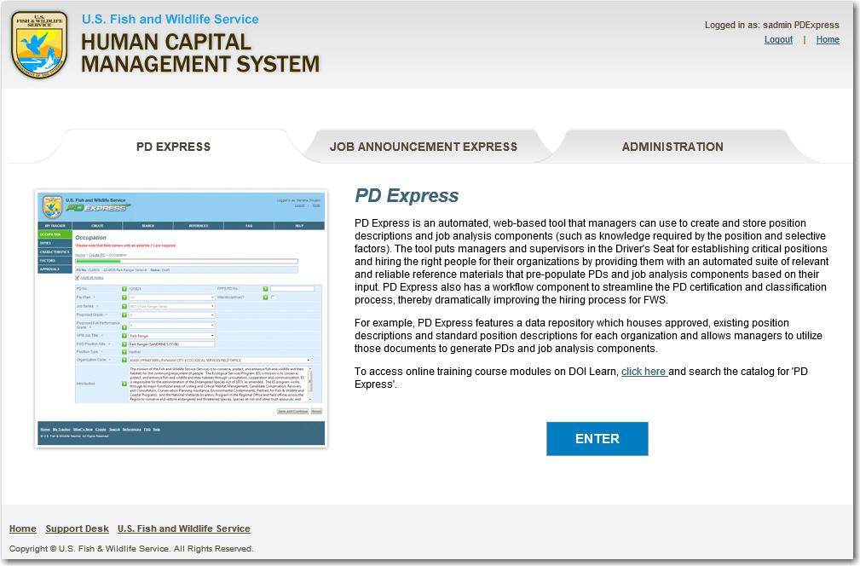

# How the JAX module interfaces with PD Express and USA Staffing for Recruiting purposes

The JAX module and the PD Express module are partners in the US Fish & Wildlife Classification and Recruitment portions of the Hiring Process. Where PD Express allows users to input information to define an open position within the organization, JAX takes information such as duty location, duties of the position, and KSAs for the position from the PD in PD Express, and pre-populates them into the job announcement record. This ensures that the two modules work together to define the position (in PD Express) and then quantitatively identify the position for recruiting purposes (in JAX).

USA Staffing is the one-stop shop for the US Fish & Wildlife’s recruiting needs. Job announcements are exported to USA Staffing, and then posted on USA Jobs, where candidates can review the open positions, and apply to those that they deem suitable.

With regard to JAX, once a job announcement record is completed in the module, it can be exported to USA Staffing. Doing so allows the position to be viewable in USA Jobs, applied to by potential candidates, and allows these candidates to be ranked based on a series of factors identified in the JAX module. This is quite beneficial, as this ranking of selective factors identified in JAX, is used by USA Staffing to rank candidates so that the most qualified candidates are identified automatically.

Logging in to JAX

**HELP**

For login and access errors, the proper action is to contact your Regional Administrator for assistance.

Click Support Desk on the bottom of the JAX screen to log a request/issue.

You can help your Regional Administrator track the problem more quickly if you provide the error message in your request.

To login to JAX, you must actually login to the HCMS module by accessing <https://hcms.fws.doi.net/HCMS/training>.

Clicking the Enter button presented when you first come to the Welcome Screen displays the Notice of Monitoring page. Be sure to read the notice, as failure to understand and adhere to the terms of use of PD Express and JAX can result in disciplinary action, including job termination. After reading the Notice of Monitoring screen, click the Accept button to indicate your understanding and agreement to comply with the notice.

Your login to the JAX module is synchronized with your Active Directory account (e.g. [user\_name@fws.gov](mailto:user_name@fws.gov)). Access, modifications, and approvals in JAX are tracked using your login, and it’s important to note that if your network password changes, so too will your JAX password.

**HELP**

For security reasons, JAX is set to automatically log out inactive users after 30 minutes of inactivity.

## To login:

1. **Enter your user name** (e.g. [user\_name@fws.gov](mailto:user_name@fws.gov))
2. **Enter your Active Directory password**
3. **Click Login**.

After logging in, you will see the Home Page – which displays either two or three tabs across the top, based on your permissions. At a minimum, you will see the PD Express and the JAX tabs. If your permissions allow, you will also see the Admin tab.

1. Click on the JAX tab, and you will see a brief description of the module as well as some of the benefits and features of the JAX module.
2. Click the ENTER button to enter the JAX module.

After entering the JAX module, you will see the JAX Home Page – which displays the “My Tracker” dashboard. This is where you will manage your In-Progress job announcements, as well as where you will begin to create new job announcements.

# Explore “Menu” Options

Within JAX, there are only two menu items at the top of the screen. These are “MENU” and “ABOUT”. Each of these two items has drop-down items that are available for navigating through the JAX Module. Let’s explore the “MENU” options:

## c.MENU.jpg

## My Tracker

Once logged in, this is the dashboard that shows the status of in-progress job announcements. This is where you will manage your in-progress job announcements.

## Create

This section allows you the option of creating a job announcement, either by creating new, or by copying from an existing published job announcement.

## Search

This section allows you to search for information using a Basic, Keyword, or Advanced Search. Basic searches allow you to search using a JAX ID, PD Express PD ID, FPPS PD number, or Vacancy ID. Key word searches allow you to search using keywords that you define for the Job Analysis, Category Rating, or Job Questionnaire for a published job announcement. The Advanced Search allows you to search for a job announcement using the Job Series and JAX status – and provides areas to identify the job announcement for which you are searching in more detail – including areas to enter information such as the Grade, OPM Title, Region, Organizational Code, or Author. Regardless of what method you use to search, search results will appear at the bottom of the Search window, where you can use them to find appropriate published job announcements from which you can create a new job announcement, or find in-progress job announcements that you wish to work with.

# Explore “ABOUT” Options

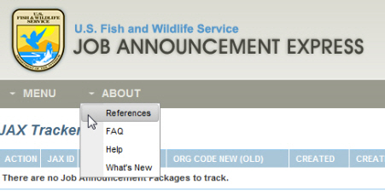

## References

This section contains additional materials to assist you when you are using JAX, such as links to training materials and process guidelines.

## FAQ

This section provides a listing of Frequently Asked Questions, and their answers. Hopefully, if you have a question, you can find the answer quickly in the FAQs section.

## Help

This section includes PDF versions of the JAX training files and the quick reference guide.

## What’s New

This section provides announcements of new features and functions to the JAX module.

## e. LOGOUT AND HOME.jpgLogout and Home

Finally, there are Logout and Home links in the upper right corner of the screen. Logout allows you to logout of the HCMS entirely. Choosing this logout link will require you to log back in to HCMS if you wish to continue working in either PD Express or JAX. The Home link will return you to the HCMS home screen where you can choose to enter either PD Express or JAX – or Admin if you have administrative rights.

## Links at the bottom of the screen



**ON TRACK**….   
The **Support Desk** allows users to log requests for administrative activities into the Issue Tracker.. The issue tracker functions exactly as in PD Express, with the addition of JAX issues that can be logged as well, to make the Issue Tracker relevant to the entire HCMS System.

There are links at the bottom of the JAX window to Home, Support Desk, My Tracker, What’s New, Create, Search, References, FAQ, Help, and a link to the U.S. Fish & Wildlife home page. These all perform the same functions as those mentioned above, and are provided as a redundant method by which you can access those areas.

# \*\*You Try It \*\* EXERCISE

## Login to JAX and Explore the Navigation

Upon completion of this exercise, you will have successfully demonstrated use of your username and password to access JAX. Once logged in, take the opportunity to become familiar with navigation using the menu. Click ABOUT, and then References, FAQs, Help, and What’s New. Then click MENU and click on My Tracker, Create, and Search to access respective screens.

**YOU TRY IT C:\Users\NTC\AppData\Local\Microsoft\Windows\Temporary Internet Files\Content.IE5\BPZOI6JZ\MC900299533[1].wmf**

1. Access the JAX Training Site at <http://hcms.fws.doi.net/training>
2. Click Enter
3. Read the Notice and Click ACCEPT
4. Enter your FWS Active Directory Username and Password.
5. Click OK.
6. Click on the JAX Tab
7. Click ENTER
8. Click ABOUT and then browse the links presented there.
9. Click MENU and browse the links presented there.

# My Tracker Dashboard – In Detail

Now, let’s look at the My Tracker Dashboard and Search Function. Note that we won’t cover the References, FAQs, Help, or What’s New, since those are pretty self-explanatory. And the Create menu option will be covered in detail in Module 3: Create a Job Announcement.

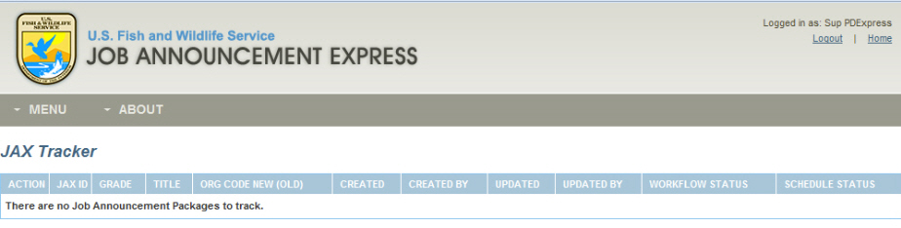

The My Tracker dashboard lists job announcements that are currently in progress and viewable based on account roles and access rights. If you are a Hiring Manager, when you login to JAX the first time, your My Tracker dashboard will be empty, since you will have no in-progress job announcements. Once you get started in the system though, your in-progress job announcements will display in the My Tracker for viewing and/or editing. Now, let’s take a few moments to explore the My Tracker dashboard.

**ON TRACK**….

You can sort the My Tracker dashboard to allow you to more easily find the job announcement you need.

To sort each column, click on the column heading.

A sorted column will display a small arrow icon to indicate an ascending or descending order.

## Action

This column provides a dropdown list of the actions that you can take for each of the in-progress job announcements listed in the My Tracker Dashboard. The options available depend on the job announcement status as well as your account settings (options include: View, Edit, Continue Edit, and Finish Edit.)

## JAX ID

This column provides an auto generated number unique to each job announcement. This number is useful when referring to your job announcements or using the SEARCH function to search for it.

## Grade

This column provides the pay grade at which you plan to advertise the position (OPM enforces a maximum of 2 pay grades).

## Title

This column provides the OPM Title of the position (usually derived from the PD) during the JAX creation process).

## Org Code New (Old)

This column provides the new FBMS Org Code number and the original Org Code (old organization code) for the same position (for historical purposes).

## Created / Created By

These two columns provide the date on which the job announcement was created, and the name of the individual who initiated the job announcement.

## Updated / Updated By

These two columns provide the date of the last update to the job announcement, as well as the name of the individual who last updated the job announcement.

## Workflow Status

This column provides the current workflow status of the in-process job announcements.

**ON TRACK**….

The **Status** of a job announcement determines who can work on it as well as the type of possible action. A JA can be in one of 6 statuses (Draft, Review, Revise, Final Review, Published, and Inactive.)

***Draft***: The job announcement is initiated by the Creator.

***Review***: The job announcement is in review by HR for Compliance.   
***Revise***: The job announcement is being revised and signed by the Creator.

***Final Review***: The job announcement is in final review and will be signed and Published by HR.

***Published***: The job announcement is certified, completed and removed from the My Tracker dashboard.

***Inactive***: The job announcement is no longer available for use (*A job announcement can be manually set to inactive when it is no longer valid or useful.*)

## Schedule Status

**ON TRACK**….

The **Schedule** indicates whether the job announcement is being addressed on-schedule.

This column provides the current schedule timing relative to workflow. It can be either **On Track**, **Warning**, or **Escalated**.

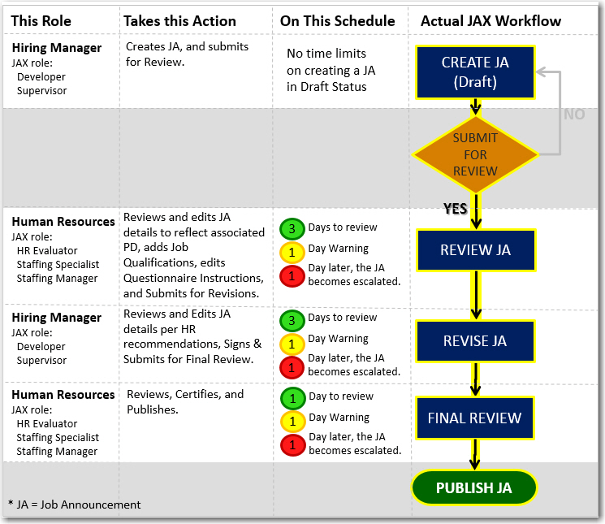

## Page Count and Navigation

Although this is not a column like the rest of the items in the My Tracker dashboard, it’s important to note that the My Tracker dashboard displays in-progress job announcements in groups of 10. If you have more than 10 in-progress job announcements, you will see a numerical listing of pages, as well as navigational icons to allow you to navigate between pages.

## Locked/Unavailable Icon

**ON TRACK**….

When **LOCKED**, the JA is only available for editing to the user currently working in the JA.

When **UNLOCKED**, the JA is available for access by anyone with proper permissions.

Although this is not a column like the rest of the items in the My Tracker dashboard, this is an important icon on this screen. A job announcement is created in collaboration between the HM and HR. For this reason, more than one user may have rights to edit the same announcement at the same time. To prevent multiple users simultaneously accessing the same job announcement, the individual announcement is “locked” when another user is editing it. Note that you can mouse over the Locked icon to see who is editing the JA, and how long it has been locked.

# \*\*You Try It \*\* EXERCISE

**YOU TRY IT C:\Users\NTC\AppData\Local\Microsoft\Windows\Temporary Internet Files\Content.IE5\BPZOI6JZ\MC900299533[1].wmf**

1. Find the “MY Tracker” Activity Sheet at the back of this manual.
2. Review the data, and respond appropriately.
3. When you have finished, compare your answers to the Answer Key

## Interpret the My Tracker dashboard

Upon completion of this exercise, you will have successfully demonstrated your understanding of the My Tracker dashboard. Use the screen shot and questions provided in your Activity Sheets to complete this exercise. Write your answers in the spaces provided on the Activity Sheets. When you are finished, the Instructor will review the correct answers with the class.

# Searching for Job Announcements

Searching for job announcements provides you with more flexibility in creating new job announcements – since you can search for existing announcements related to the PD for which you are recruiting, and use the existing job announcements either as is, or as the basis for creating a new job announcement. There are three ways that you can search the JAX module – a Basic Search, a Keyword Search, and an Advanced Search. We’ll tell you about all three here.

## Basic Search

The Basic Search function allows you to simply type in the number of the JAX ID, the PD Express PD number, FPPS PD number, or Vacancy ID, and click SEARCH. If results are returned that match your search criteria, they will displayed to you.

## To Perform a Basic Search:

1. **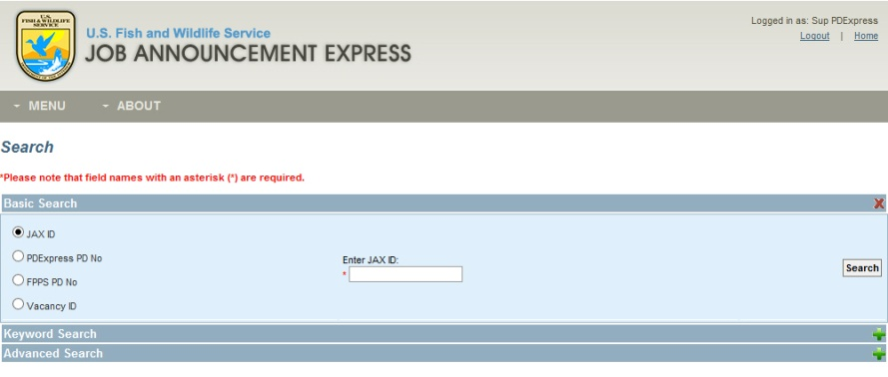Click MENU**
2. **Select SEARCH**
3. **Type in the JAX ID, the PD Express PD number, the FPPS PD number, or the Vacancy ID**
4. **Click SEARCH**

## Keyword Search

The Keyword Search function allows you to type in a keyword and then choose whether to search in Job Analysis, Category Rating, or Job Questionnaire data for results. This is especially useful when creating a new job announcement for which you need to find similar wordings or questions that are applicable from other published packages. If results are returned that match your search criteria, they will be displayed to you.

## 26. ADVANCED SEARCH.jpgTo Perform a Keyword Search:

1. **Click MENU**
2. **Select SEARCH**
3. **Select Keyword Search**
4. **Select Job Analysis, Category Rating, or Job Questionnaire**
5. **Enter relevant Keyword(s)**
6. **Click SEARCH**

**ON TRACK**….

You can view ANY Published Packages regardless of Organization. However, you may only view In-Process packages in the Organization to which you have access.

## Advanced Search

The Advanced Search function allows you to define specific criteria for your search. You must choose the Job Series and Status of the job announcement when using this Advanced Search function, and you can choose whether to define the Grade, OPM Title, Region, Org Code, Author, and whether the announcement resulted in a successful hire or not, although those fields are optional.

## To Perform an Advanced Search:

1. **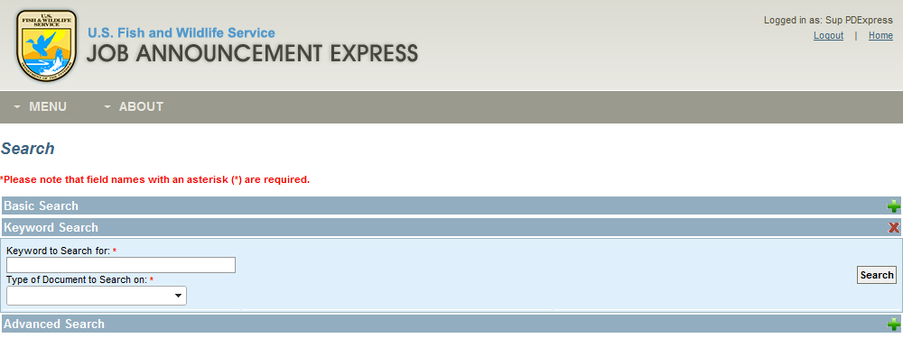Click MENU**
2. **Select SEARCH**
3. **Select Advanced Search**
4. **Enter the Job Series and Status of the job announcement** for which you are searching
5. Optionally, you can define the Grade, OPM Title, Region, Org Code, Author, and/or whether the job announcement resulted in a successful hire
6. **Click SEARCH**

# \*\*You Try It \*\* EXERCISE

**YOU TRY IT C:\Users\NTC\AppData\Local\Microsoft\Windows\Temporary Internet Files\Content.IE5\BPZOI6JZ\MC900299533[1].wmf**

1. Click MENU
2. Select SEARCH
3. On the Basic Search screen, select the JAX ID radio button.
4. Type 1010 in the Keyword Entry box.
5. Click SEARCH.

## Search JAX

Upon completion of this exercise, you will have successfully demonstrated use of the JAX Search Function.

## Advanced Search Results:

When reviewing the results of an advanced Search, you can view the job announcements that are returned in the results, if any.

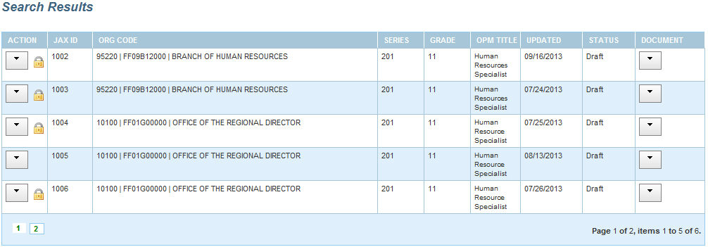

This ACTION column that displays in the SEARCH RESULTS provides a dropdown list of the actions that you can take for each of the returned results. The options available depend on the job announcement status as well as your account settings (options include: View, Edit, Continue Edit, and Finish Edit.)

# Conclusion

This completes Module 2: Getting Started in the HCMS. You should have a thorough understanding of how to login to the HCMS, the different tabs in the JAX module, and how to use the My Tracker and Search functions within the JAX module.

This page intentionally left blank.



##### MODULE 3: CREATING A JOB ANNOUNCEMENT

##### (HM/HR/ADMIN)

Module 3: Create a Job Announcement (HM/HR/ADMIN)

Creating a job announcement has either two or three separate components, or tasks – depending upon the recruitment option that you choose for your job announcement. These are (1) the Creation of the Job Analysis – where KSAs are created and/or associated to each of the major Duties of the position; (2) the creation of the Job Questionnaire – where Recruiting questions are created and correlated to each KSA; and (3) the creation of the Category Ratings – for announcements that will be recruited both inside and outside of the government (all sources/DEU) – where ratings are created in order to identify the most qualified candidates for the position.

# Initiate a NEW Job Announcement

The JAX module allows you to create a new job announcement from a published PD. Since these modules are integrated in HCMS, the data exchange between PD Express and JAX is transparent to you. All you will need to know is the basic information for the position, and PD Express will populate the creation screen with applicable PDs from which you can choose.

## To initiate a New Job Announcement:SHOT 11 - MENU CREATE.jpg

* 1. Ensure that you are logged into HCMS, and in the JAX module
  2. **Click the MENU** item
  3. **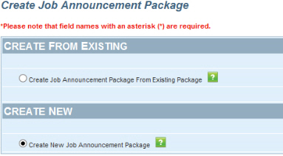Select CREATE** from the drop-down list
  4. **Choose the Create New Job Announcement radio button**,
  5. **Click SUBMIT**

\*\*You Try It \*\* EXERCISE

**YOU TRY IT C:\Users\NTC\AppData\Local\Microsoft\Windows\Temporary Internet Files\Content.IE5\BPZOI6JZ\MC900299533[1].wmf**

1. Click MENU
2. Select CREATE
3. Select the radio button beside Create New Job Announcement
4. Click SUBMIT

## Initiate a New Job Announcement.

Upon completion of this exercise, you will have successfully the ability to initiate a new job announcement in JAX.

# 8. JAX _ CREATE JOB ANNOUNCEMENT.jpgCreating a NEW Job Announcement Step 1: Complete the Job Analysis

Once a New job announcement is initiated, the next step is to complete the Job Analysis. The Job Analysis is used to determine the most relevant Knowledge, Skills, and Abilities (KSAs) from each Major Duty of the position. **There are three sections to the Job Analysis – the Position Information, the Duty/KSAs and the Final KSAs**. To get started on the Job Analysis, you’ll begin at the Position Information Screen, where you’ll define the type of Announcement you want to create.

## To complete the Job Analysis / Announcement Information Screen:

**HELP**

Some information such as Duties, KSAs, etc. are pre-populated from the PD.

1. **Choose the Pay Plan, Series, and Organization** from the drop down boxes.
2. **Select the advertised grade for the announcement** (or the highest advertised grade if you are advertising across two grades), and then
3. The applicable PDs will populate in the PD dropdown. **Choose the PD that is most applicable**. Note that if you are recruiting across two grade levels, then you will need to select the PD associated to each grade level for which you are recruiting.

**ON TRACK….**

All recruiting sources outside of the Government must have a Category Rating for the job announcement. The Category Rating helps to further enable filtering of candidates among all candidates that meet the basic/minimum qualifications, and enables the division of qualified candidates into Qualified, Well Qualified, and Best Qualified. Note that Category Ratings are based on Qualifying Statements that are defined for each KSA.

1. **Define the Recruitment option**. The recruitment options allow you to define how the announcement will be recruited. Merit Promotion (MP) should be selected if you are recruiting within the government, while Delegated Examining Unit (DEU) should be selected if you are advertising across all sources (inside and outside of the government). Note that selecting DEU automatically selects MP as well.

\*\**Note that if DEU is NOT selected, then the Category Rating item will disappear from the top menu bar, since it is not necessary to provide category ratings if you are not recruiting outside of the Government. However, you can elect to create a CR for non-DEU packages after the Job Questionnaire.* \*\*

|  |  |  |
| --- | --- | --- |
| **Recruitment Option** | **When Do I use it?** | **What is the JAX impact?** |
| Delegated Examining Unit (DEU) | When you want to recruit both inside and outside of the Federal Government. | A Category Rating is REQUIRED |
| Merit Promotion (MP) | When you want to recruit inside the Federal Government only. | A Category Rating is OPTIONAL |
| Excepted | When you want to hire interns or recent graduates (ex. pathways program) | A Category Rating is OPTIONAL |

There are also a few other optional items on this screen that you can identify. These include:

1. The Interdisciplinary box allows you to indicate that your JA is to be related to more than one professional occupation.

**ON TRACK….**

The JAX ID (JA number) is the easiest method to find your JA later. Keep track of the JA numbers that you create so that you can always find them easily.

1. The JAX Grade Level box allows you to indicate that this is to be a two-grade announcement.
2. The Duty Location is automatically populated by PD Express, but can be manually edited.
3. Once you have completed the Job Analysis/Position Information screen, **click SAVE AND CONTINUE**. This action will create a new job announcement with a unique JAX ID in the system. **Review and edit all of the information on this screen** as necessary. Then, **click SAVE AND CONTINUE.**

At this point, you’ll notice that a new header has been added below the top menu bar. This header indicates the items required to create a new job announcement (Category Rating is only required if DEU is selected as the recruitment option on the Job Analysis. If you do not select DEU, then only the Job Analysis and Job Questionnaire are required.)

The header will allow you to keep track of where you are in the creation process, and will also serve as navigational items in case you find that you need to return to a previous step in the process. Because the information in each section is predicated on completion of the previous section, it’s advantageous to let the system guide the development of your job announcement (e.g. Complete the Job Analysis, THEN the Job Questionnaire, and THEN the Category Rating items), although you can develop the Announcement in any order you choose.

# \*\*You Try It \*\* EXERCISE

## Complete the Job Analysis/Position Information screen.

**YOU TRY IT C:\Users\NTC\AppData\Local\Microsoft\Windows\Temporary Internet Files\Content.IE5\BPZOI6JZ\MC900299533[1].wmf**

1. Choose Pay Plan GS
2. Choose your Series
3. Choose your Org Code
4. Choose your Grade
5. Select your PD from the drop-down (Note: Contact your Regional HR Office if your PD is not in the PD Express so that it can be added.
6. Select DEU
7. Click SAVE AND CONTINUE

Upon completion of this exercise, you will have successfully completed the Job Analysis / Position Information screen.

## Define the Position’s Duties and KSAs.

After the Job Analysis/Position Information is completed, the next step in   
finalizing the Job Analysis is the Duty/KSAs. This screen will list at least one major duty which the candidate will perform on the job, and the data comes directly from the information contained in the PD. You must have at least 1 major Job Analysis Duty listed, and no more than 8 Job Analysis Major Duties, and combined they must equal 100% of the position responsibilities. Remember, the more specific you are, the more specific your announcement and resulting candidate questionnaires will be. On this screen you can edit the Duties that are provided, and you can edit existing KSAs associated with each of the Major Duties, or you can add new KSAs. It’s important to note that the KSAs must directly relate to performance on the job – and must clearly demonstrate what is required in order for the qualified individual to be able to perform the duties of the job.

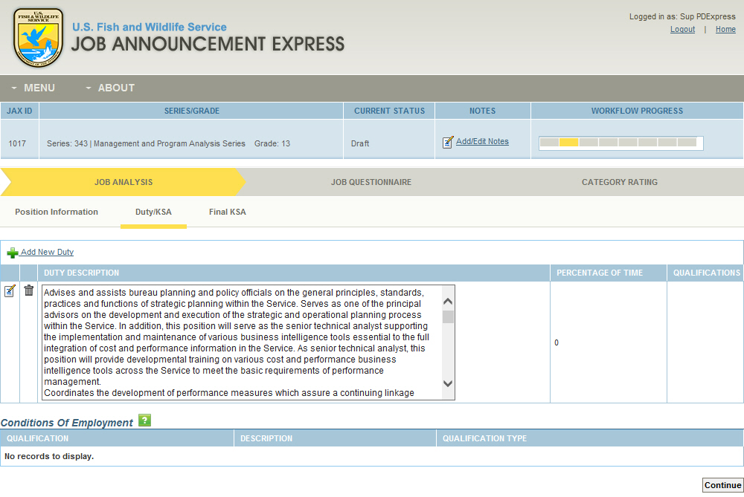

## To complete the Job Analysis / Duty/KSA Screen:

1. **Review the major duties** that are prepopulated from PD Express. If you need to edit any of the duties, click the EDIT icon, and edit the duty as you see fit.
   1. **To edit an existing duty**:
      1. Click the Edit icon to the left of the Duty.
      2. Click SAVE to save your changes.
      3. Once you have made all the necessary edits to the existing Duty, click CLOSE to return to the Job Analysis Duties Screen.
   2. If you need **to delete an existing duty**, even one prepopulated by PD Express:
      1. Click the Delete icon to the left of the duty which you wish to delete. It’s important to note that once a duty and its associated KSAs and Task Statements are deleted, you cannot reverse this action.

**HELP**

If a single duty is populated from the PD, and you elect to edit it into smaller more discrete duties, you MUST change the percentage of time upon which each duty is performed. This is done in the EDIT field for the Duty. If you do not take this step, you will not be able to move forward to finalize your KSAs. The TOTAL of all duties must equal 100%

* 1. If you need **to add a new Duty**:
     1. Click the Add New Duty link.
     2. Enter up to 3 lines of text that summarize the duty or task to be performed on the job.
     3. Choose the percentage of time that this duty is performed during the work period.
     4. Click SAVE to save your new duty.

Note that the main reason to edit duties is if the PD prepopulates only a single very large duty. In these cases, it’s important to both edit the original duty as well as to create multiple new duties – effectively breaking the original single large duty into multiple smaller major duties.

That way, each duty would comprise only a single actual task to be performed – making it easier to associate KSAs to the individual duties. However, it is imperative that when editing duties or creating new duties, that there be nothing NEW on the Job Analysis that is not covered by the PD. While you can break a single duty from the PD into several duties, you can NOT add net new duties to the Job Analysis that are not captured in the PD. Doing so will require revisions (and reclassification) of the original PD.

**ON TRACK….**

Note that all KSAs come from previously created FWS KSAs in USA Jobs by series and grade – the Hiring Manager can determine how many of these KSAs to add, and how specific to be on the descriptions. Just remember, the benefit to adding more KSAs is that the KSAs determine what questions you can ask on the questionnaire that prospective employees must answer – and can help you to narrow down the field of prospective candidates.

1. **Review the KSAs** that are prepopulated from PD Express or add New KSAs if none prepopulated. If you need to edit any of the KSAs, click the EDIT icon, and edit the duty as you see fit**.**
   1. **To edit an existing KSA**:
      1. Click the Edit icon to the left of the KSA.
      2. Click SAVE to save your changes.
      3. Once you have made all the necessary edits to the existing KSA, click CLOSE to return to the Job Analysis KSA Screen.
   2. If you need **to delete an existing KSA**, even one prepopulated by PD Express:
      1. Click the Delete icon to the left of the KSA which you wish to delete. It’s important to note that once a KSA and its associated Task Statements are deleted, you cannot reverse this action.
   3. If you need **to add a new KSA**:
      1. Click the Add New Duty KSA link.
      2. Here you can decide to **either Copy the KSAs directly from your Duty Description, or select from a pre-populated list of standard KSAs from the library of KSAs associated with this series and grade**.
      3. Click SAVE to save your new duty.

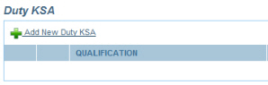

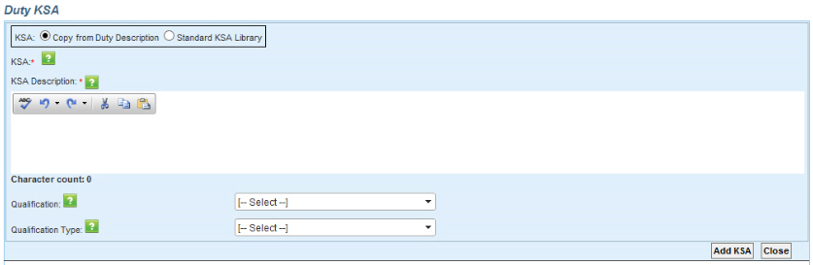

* + - 1. **To use KSAs copied from your Duty Description**, check the Copied from Duty Description radio button, and use your standard Windows Copy function (CTRL + C) to copy any wording from the Duty and paste it into the KSA text area. Then, you can edit the content as you see fit.
      2. **To use KSAs from the Standard Library**, check the Standard KSA Library radio button, and then choose a KSA from the drop down list that most clearly reflects what the individual must know, have done, or be able to do in order to perform the Duty that you added above. You can make edits to the KSA selected from the KSA library to ensure that the KSA exactly meets the needs of the position for which you are recruiting.

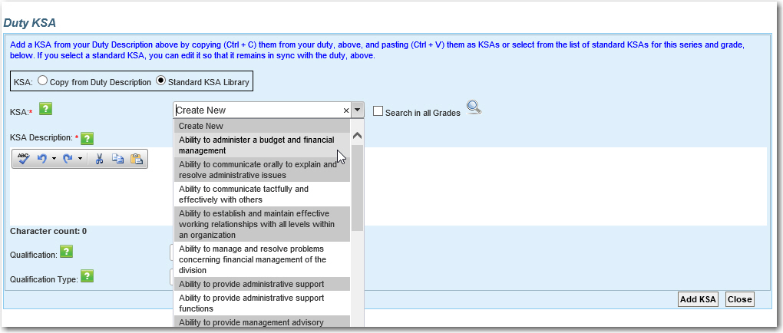

Note that you will see all KSAs in the grade selected, for the series selected. You can then expand the KSA list to see all KSAs regardless of grade for the selected series, and choose the ones that apply. In addition, you can also perform a keyword search for Duty KSAs – searching through either the KSAs in the grade of your job announcement, or through all KSAs in the series. In either case, you must choose the appropriate KSAs for your position. If you do not or cannot find the KSAs that you need for your JAX, you can select “other” from the drop-down and write your own, new KSA.

**ON TRACK….**

JAXallow HMs to define whether KSAs are **Selective Factors** – meaning that candidates MUST possess the KSA to be considered; **Quality Ranking Factors** are KSAs that determine how qualified a candidate is based on whether they possess the KSA; **KSAs** are neither a Selective Factor nor a Quality Ranking Factor.

* + - 1. Once the KSA is selected, the KSA Description is automatically populated, but you can **edit this KSA description** to be more specific if you wish. To do so,
         1. **Choose the Qualification Type** for the KSA – such as knowledge, skill, ability, etc.
         2. **Choose the Type of KSA**–either Selective Factor, KSA-Quality Ranking Factor, or KSA.

**HELP**

Once a KSA is defined as a Selective Factor, it is considered a Final KSA and will be included in the Job Questionnaire.

* + - * 1. **Click ADD KSA**.
        2. Continue to add KSAs to your Duty until you have added everything that you feel is necessary.
        3. Once you have added all KSAs, **click CLOSE** to return to the Job Analysis Duty/KSA Screen.
        4. Then, **repeat** the above process **for all Major Duties** for the position.
        5. Once all Job Analysis Duties and associated KSAs are completed, **click CONTINUE** to go to the Final KSA Screen.

\*\*You Try It \*\* EXERCISE

**YOU TRY IT C:\Users\NTC\AppData\Local\Microsoft\Windows\Temporary Internet Files\Content.IE5\BPZOI6JZ\MC900299533[1].wmf**

1. Click ADD DUTY/KSA.
2. Choose the “From Existing Library Radio button.
3. Choose the second KSA from the dropdown list.
4. Select KNOWLEDGE as the Qualification Type.
5. Select KSA-Quality Ranking Factor as the KSA Type.
6. Click ADD KSA.
7. Click CONITNUE.

**YOU TRY IT C:\Users\NTC\AppData\Local\Microsoft\Windows\Temporary Internet Files\Content.IE5\BPZOI6JZ\MC900299533[1].wmf**

1. Click the EDIT icon to edit the existing duty..
2. Copy part of the existing duty text and cut it from the screen (CTRL+C then CTRL+X)
3. Change time to 50%.
4. Click SAVE.
5. Click ADD NEW DUTY.
6. Paste your copied text (CTRL +Y)
7. Change time to 50%.
   * 1. Select check the Standard KSA Library radio button, and then choose a KSA from the drop down list that defines what the individual must know, have done, or be able to do in order to perform the Duty that you added above.

## Complete the Job Analysis/ Duty/KSAs screen.

Upon completion of this exercise, you will have successfully completed the Job Analysis / Duty/KSAs screen.

**ON TRACK….**

Final KSAs are used to create the Questionnaire on USAJobs. The importance scale values help you to define your top KSAs, so that you know which ones to assess candidates on. You cannot exceed 8 final KSAs, so the scale is a good way of paring down the KSAs to determine FINAL KSAs, and rank each FINAL KSA according to its value. Note that the value scale is not required, although you MUST define at least 1 FINAL KSA.

## Define the Position’s Final KSAs

The third and last step in creating the Job Analysis is the Final KSA Screen. The Final KSA Screen is where you will define the importance of each KSA (optional), and select the final KSAs (maximum of 8) about which you will ask questions in your Job Questionnaire. You can rank each KSA in order of importance, but it’s important to note that ranking all KSAs as Very Important, provides little value in having multiple KSAs.

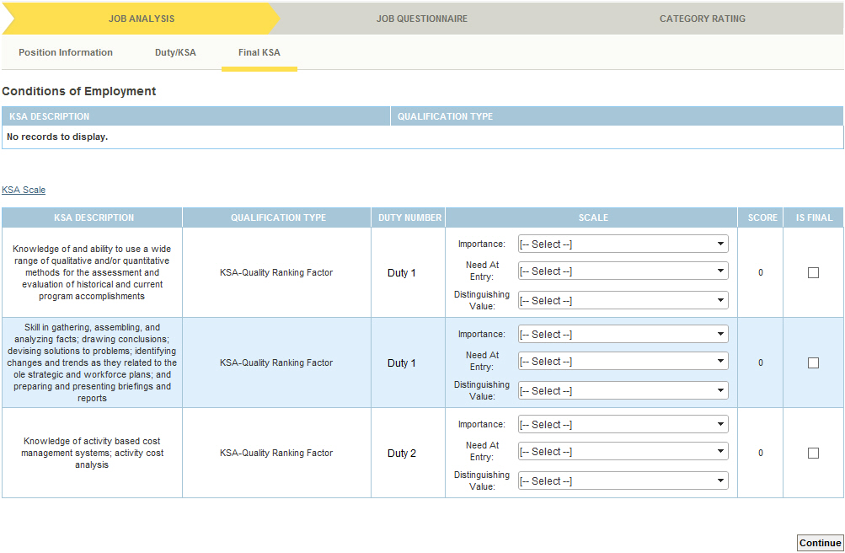

## To complete the Job Analysis / Final KSAs Screen:

1. **For each KSA, define the Importance, Need At Entry, and Distinguishing Value** from the drop down lists.

Note that any KSAs defined as “Selective Factors” on the previous screen are considered “FINAL” and cannot be unchecked. In order to change these, you must go back into the Duty/KSA Screen, Edit the Duty to which the KSA is assigned, and then change the individual KSA from Selective Factor to either KSA or KSA-Quality Ranking Factor.

1. When you are satisfied that each KSA is accurately weighted, **click the IS FINAL box** on the right of each KSA, using the importance scale to help define the most important KSAs.

Note that you must have at least 1 KSA indicated as “FINAL”, but no more than 8 KSAs indicated as “FINAL”. These “FINAL” KSAs are the ones upon which your Job Questionnaire will be based.

1. **Click CONTINUE** to finalize the Job Analysis Portion of the process.

**YOU TRY IT C:\Users\NTC\AppData\Local\Microsoft\Windows\Temporary Internet Files\Content.IE5\BPZOI6JZ\MC900299533[1].wmf**

1. Define your KSA as VERY IMPORTANT.
2. Select MUST BE ACQUIRED WITHIN 4-6MONTHS for your KSA.
3. Select VERY VALUABLE.
4. Click the IS FINAL checkbox.
5. Click CONTINUE.

# \*\*You Try It \*\* EXERCISE

## Complete the Job Analysis / Final KSAs screen.

Upon completion of this exercise, you will have successfully completed the Job Analysis / Final KSAs screen.

Creating a NEW Job Announcement Step 2: Complete the Job Questionnaire

**HELP**

HR is responsible for the Job Questionnaire / Qualifications Screen, so HMs will see this as skipped. Once HR has completed this screen in Review, you be directed here during the Revise phase, to review and make edits as appropriate.

After completing the Job Analysis, the next step toward completing a new job announcement is to complete the Job Questionnaire. The Job Questionnaire is used to define relevant questions for each KSA for the position. **There are three sections to the Job Questionnaire – Qualification, KSA and Final**. To get started on the Job Questionnaire, you’ll begin at the KSA Screen.

# 16. JOB QUESTIONNAIRE.jpg

**To** **complete the Job Questionnaire / KSA Screen:**

**ON TRACK….**

The Job Questionnaire is the actual list of questions that the job applicant will respond to on USAJobs. This section of JAX development requires you to actually determine the questions that should be asked, and the answers that are appropriate as responses.

The KSA Screen displays all of the KSAs that you identified as FINAL on the Job Analysis / Final KSAs screen. You must now develop relevant questions that will appear on the USAStaffing/USAJobs site for your position announcement, and for which applicants must respond. To develop the questions for each KSA:

1. **Click on the Edit icon** to the left of the first KSA.
2. The Add/Edit Job Questionnaire KSA Screen will appear.
3. **Click the ADD NEW TASK STATEMENT link** to begin adding task statements for your KSA.

Here, you can add an existing Task Statement (e.g. a question that has been previously asked for this KSA), or you can add a new Task Statement (e.g. a question that is not already available on the prepopulated list.) Instructions for each KSA and response are provided.

1. To **add an existing Task Statement**:
   * 1. Click the dropdown arrow to the right of the Task Statement Field to see a list of all Task Statements previously asked for this KSA. If this field is blank, you can click the Search All Grades checkbox to get a list of all task statements for this Series regardless of grade. You can further refine this search by keyword to narrow your results.
     2. Choose the most appropriate Task Statement from the scrollable list to populate the Task Statement field, and then edit as needed.
2. To **add a new Task Statement**:
   * 1. Click on the dropdown arrow to the right of the Task Statement Field and select Create New (the first option in the drop-down).
     2. Type in the task statement, or question, which will be asked of potential applicants in the Task Statement Field.
     3. **Click SAVE** to save, and then close your Task Statement.
     4. You must have at least one task statement (questions) for each KSA. However, the JAX module recommends four-five task statements for each KSA in order to provide the most complete set of questions by which applicants can demonstrate that they have the appropriate knowledge, skills, and/or abilities to adequately perform the duties of the position.
3. Once you have an appropriate number of Task Statements for the KSA, **click CLOSE to return to the list of KSAs and repeat the above process to add Task Statements to each KSA** until each has at least four or five Task Statements.
4. When you have finished adding Task Statements for all KSAs, **click CONTINUE to** go to the Final KSA Screen to review the Final KSAs.

**YOU TRY IT C:\Users\NTC\AppData\Local\Microsoft\Windows\Temporary Internet Files\Content.IE5\BPZOI6JZ\MC900299533[1].wmf**

1. Click the EDIT icon beside your KSA.
2. Click ADD NEW TASK STATEMENT.
3. Click the Search All Grades checkbox.
4. Choose the last statement from the list.
5. Click SAVE TASK STATEMENT.
6. Add two more task statements following the steps above.
7. Click CONTINUE.

# \*\*You Try It \*\* EXERCISE

## Complete the Job Questionnaire / KSAs screen.

Upon completion of this exercise, you will have successfully completed the Job Questionnaire / KSAs screen.

## To complete the Job Questionnaire / Final Screen:

The Final Screen displays the KSAs that you identified as FINAL on the Job Analysis / Final KSAs screen and for which you identified Task Statements or questions for the job Questionnaire. It also displays all of the Qualifications HR added on the Qualification screen (i.e., Minimum Qualifications, Selective Factors, Basic Education Requirements, etc.). Hiring Managers can use this page to see all of their KSAs/Qualifications in one place, and click into each KSA/Qual on screen to view the associated Questions. You can also click into each question to see the responses to each, and generate a PDF of the questionnaire.

1. **Review your Task Statements** to determine if they are listed in the order of most important to least important.
2. If you wish to change the order, you can leave a note for HR about the order that you want the questions presented.
3. **Click PREVIEW REPORT** to see the Questionnaire in a pdf format that you can save to your desktop for future reference during the interview process. You can return to the KSA tab and make edits to your questionnaire, if needed.
4. **Click CONTINUE** to continue to the final step of the job announcement creation -- Category Rating if the position is DEU. If the position is not DEU, this is the last action you’ll need to take to create your job announcement at this time. You can take one of the three following actions, using the “Section Action” dropdown box on this screen:
   1. **Click Create a Category Rating (Optional)** to create an optional Category Rating for your JA
   2. **Save and Unlock** to save the job announcement for revisions/review before submitting to HR.
   3. **Send to Review to HR**  to submit the JA for HR review and approval
5. If the position is non-DEU, you’ll need to choose one of the actions above and then **click GO**.

\*\*You Try It \*\* EXERCISE

**YOU TRY IT C:\Users\NTC\AppData\Local\Microsoft\Windows\Temporary Internet Files\Content.IE5\BPZOI6JZ\MC900299533[1].wmf**

1. Click Preview Report, and then VIEW the pdf report.
2. Close the report.
3. Click Continue.  
   .

## Complete the Job Questionnaire / Final screen.

Upon completion of this exercise, you will have successfully completed the Job Questionnaire / Final screen.

# Creating a NEW Job Announcement Step 3: Complete the Category Ratings

The final step toward completing a new job announcement for positions that are DEU is to complete the Category Rating. Category ratings help to further enable candidate filtering among all candidates that meet the basic/minimum qualifications and achieve 70 points or higher from the Questionnaire.

The Category Rating allows for the division of qualified candidates into three tiers – *Qualified* (having achieved 70-80 points or higher on the questionnaire); *Well Qualified* (having achieved 81-90 points on the questionnaire); and *Highly Qualified* (having achieved 91 points or higher on the questionnaire). The determining factor for each qualification level is based on qualifying statements that describe the level of competency of a KSA that is to be tested within the questionnaire.

Things worth noting in CR: JAX provides an example CR that may be helpful to review to get an idea of what to put in each Category. Also, the system auto-populates the minimum qualification standards from OPM into the Qualified category of the CR based on the Series and Grade of the announcement you are creating. You may want to further expand on minimum qualifications for your position, being sure that there are no gaps or overlaps in the point ranges defined for each category. And finally, once finished, you can Save and Unlock the job announcement, or send to HR for review.

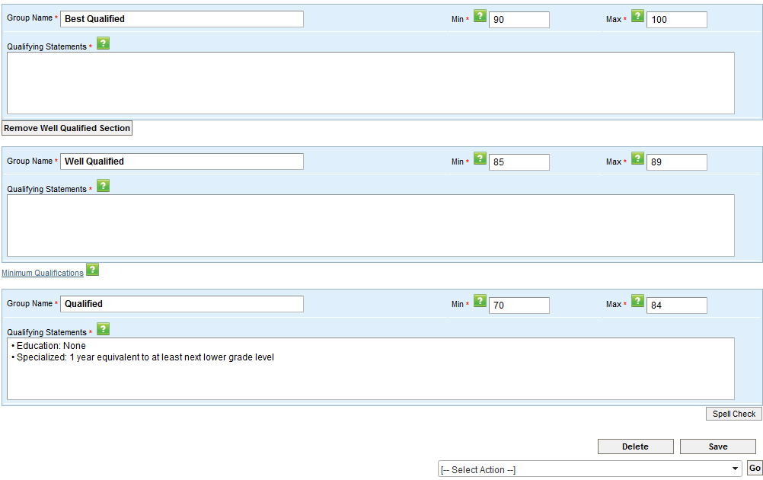

## To complete the Category Ratings:

When the Category Rating screen appears, you will see the list of final KSAs from the Job Analysis in the top area of the screen. Beneath that, you will see three areas for data input. These are: “Best Qualified”, “Well Qualified” and “Qualified”. The top and bottom sections are required, and the middle or “Well Qualified” section can be completed if desired. Reach out to HR if you want to remove this category. To complete the Category Ratings:

* + - 1. **In the “BEST QUALIFIED” field, type at least 1 qualifying statement for each KSA that would differentiate a candidate as best qualified for the position**.
      2. **Either repeat these steps for the “Well Qualified**”area, **or click on the “REMOVE WELL QUALIFIED SECTION”** to remove this section altogether, if you do not plan to use it.

**HELP**

The spell check works similarly to the spell check in Microsoft products, providing you with highlighting on the misspelled words, words that can be used to replace the misspelled words, and the ability to ignore highlighted items. When spell-check is complete, the window will disappear

* + - 1. In the “**QUALIFIED**” field, you will notice that it is auto-populated with the OPM minimum qualification standards for the position. You can further expand on these minimum qualifications using your KSAs.
      2. **Check the MIN and MAX fields** of each of the Category Ratings areas, to be sure that there is no gap in these numbers (this is especially important if you remove the “Well Qualified” section).
      3. Once you have completed the Category Ratings, **click SAVE to save your work**.
      4. Then, **click SPELL CHECK** to see any misspellings and/or unknown words that you have typed in that should be corrected.

## Save and Approve the Category Rating

Once you have completed the Category Rating, you can choose to either Save and Unlock, or to send the job announcement to HR for review. At this point, the job announcement is completed.

**YOU TRY IT C:\Users\NTC\AppData\Local\Microsoft\Windows\Temporary Internet Files\Content.IE5\BPZOI6JZ\MC900299533[1].wmf**

1. Write one Category Rating statement for each KSA for BEST QUALIFIED.
2. Click the REMOVE WELL QUALIFIED button.
3. Review the QUALIFIED statements
4. Click SAVE.
5. Click SPELL CHECK.
6. Correct any misspellings.
7. Click SAVE and UNLOCK

You may decide to Save and Unlock the job announcement if you have written notes to yourself, or if you feel like you might want to take   
another look at the job announcement or have someone else review it before sending it over to HR to review. Remember, HR will review the job announcement, make suggestions for revision, add the “Qualifications” into the Job Questionnaire, and reorder your KSAs if necessary. Then, it will get sent back to you for final revision and signature prior to publishing.

\*\*You Try It \*\* EXERCISE

## Complete the Category Ratings Screen.

Upon completion of this exercise, you will have successfully completed Category Ratings for your job announcement.

# Creating a NEW Job Announcement Step 4: Approval and Publishing

Once the job announcement is Created by the Hiring Manager, Reviewed by HR, revised and signed by the Hiring Manager, and reviewed and certified by HR, it can be published. The job announcement is published, exported by HR in UTF-8 format, and sent to USAStaffing for import into the USAJobs database. Once that is done, the job announcement will appear on USAJobs where potential candidates can review the position description (from PD Express), and apply for the position by answering relevant questions (from the JAX Job Questionnaire that you created) and submit their resumes for consideration. All applicants will be weighed as “Qualified”, “Well Qualified”, or “Best Qualified” based on the qualifying statements that you entered in the category ratings of JAX for each KSA.



# Create a Job Announcement from an EXISTING Package

Aside from being able to create a completely new job announcement, the JAX module allows you to create a job announcement from an already published, existing job announcement that is associated with a Published PD in an Org Code to which you have access. All of the data from the published job announcement and associated PD will be populated into your new job announcement, and can be edited as necessary to meet the needs of your position.

To Create from Existing, ensure that you are logged into HCMS, and in the JAX module

* 1. **Click the MENU** item
  2. **Select CREATE** from the drop-down list
  3. **Choose the Create Job Announcement from Existing radio button**, and
  4. **Click SUBMIT**

Unlike creating a NEW job announcement, when choosing the Create from Existing, the first screen you’ll see isn’t the Position Information screen, but instead the SEARCH screen. On this screen, you can search by JAX ID, PD Express PD Number, etc. – or you can use the Keyword or Advanced Search features to find a published Job Announcement that meets your needs.

**HELP**

Although in-process packages within your org code, and all published packages can be searched, only published packages that have associated published PDs within your org code can be used as the basis for creating a new job announcement.

## Search for the Package to Copy

The SEARCH function here is identical to the standard SEARCH function in this module. You will use the Search Function to search for the package that best conforms to your position and the job announcement that you want to create. To search for an existing package:

1. **Enter the JAX ID, Associated PD Express PD number, FPPS PD number, or Vacancy ID of the published announcements you’re looking for or do an advanced search of all published packages in a certain Series / Grade in your Organization.**
2. **Click SEARCH**.
3. Search Results will appear at the bottom of the screen. **Click on the dropdown arrow to the left of the job announcement** which you wish to use as the basis for your new job announcement, and
4. **Choose Copy and Start New**.

This will generate a new JAX ID and copy over all information from the package you are copying (while making most of this information editable).

# \*\*You Try It \*\* EXERCISE

**YOU TRY IT C:\Users\NTC\AppData\Local\Microsoft\Windows\Temporary Internet Files\Content.IE5\BPZOI6JZ\MC900299533[1].wmf**

1. Click MENU.
2. Click CREATE
3. Choose the Create Job Announcement from Existing radio button.
4. Click SUBMIT.
5. Enter the ID of the existing package.
6. Click SEARCH
7. Click the ACTION dropdown.
8. Choose COPY AND START NEW

## Start a new Job Announcement based on an Existing Published Package.

Upon completion of this exercise, you will have successfully initiated a new Job Announcement based on an existing package.

Once the new Job Announcement is copied over, you will be taken to the Copy from Existing Job Announcement Screen (which is similar to the Position Information screen).

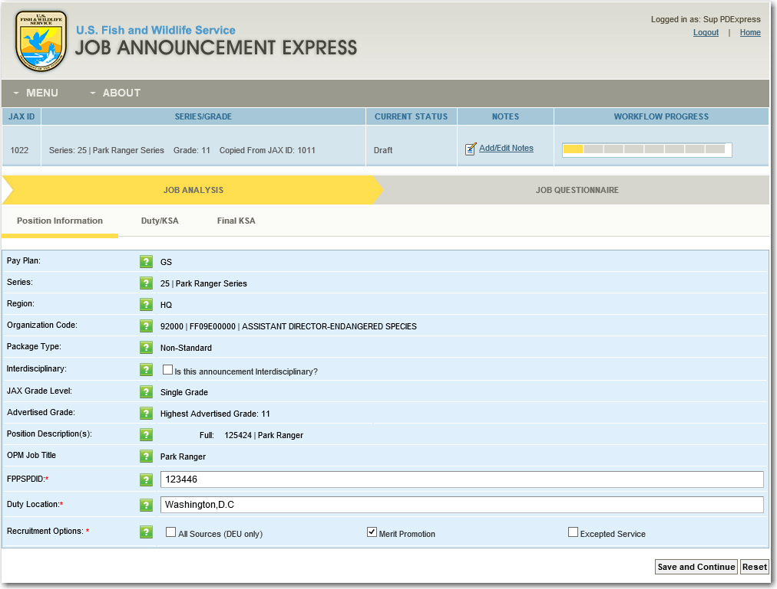

To finish Copying the package over to create your new Job Announcement:

1. **Click SAVE and CONTINUE**.

Once you have done this, the Position Information screen appears, with the new JAX ID for your job announcement, and the words “Copied from….” In the Series/Grade title area to indicate that your announcement is based on a previously published package.

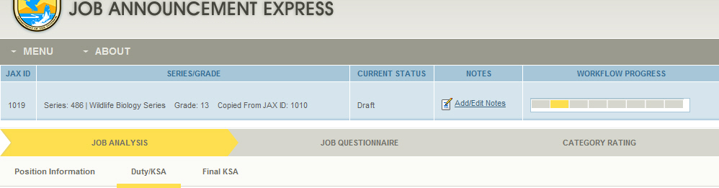

From this point on the job announcement creation process, the steps are identical to those taken when creating a NEW job announcement with one exception – all of the screens are already populated with the information from the original job announcement information. On each screen, review and edit the information as you feel necessary to best suit your new job announcement, while making sure the announcement remains in sync with the associated PD. When you have completed your review and edit of the Job Analysis, Job Questionnaire, and Category Rating (if required, or if you wish to include one when not required), you can Save and Unlock, or Save and Send to HR for Review.

Here, the draft, review, revise, final review and publish timelines and processes are the same as when creating a NEW job announcement.



##### MODULE 4: HR FUNCTIONS IN JAX

##### (HR/ADMIN)

Module 4: HR Functions in JAX (HR/ADMIN)

As an HR Professional, a portion of your time in JAX will be spent reviewing the job announcements that have been created by Hiring Managers to ensure that they align with HR regulations and with the information required for the given positions. To do so, you will login to HCMS, and chose the packages in the JAX MY TRACKER that have been assigned for your review. A few things to note when reviewing packages submitted for review by HMs:

1. **There is a NOTES link** in the blue header bar. This link is important, as it provides notes from the HM regarding any revisions or reordering of content that s/he desires. 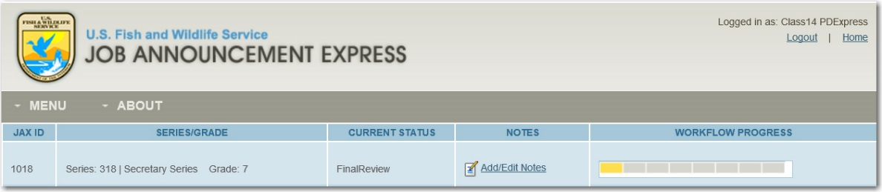
2. **You have only 3 days to review and edit** the job announcement to reflect the associated PD before it becomes set to “WARNING” status. Two days after that (after a total of five days) it will be escalated for inaction.
3. **It is important that you review EACH screen and all content** that the HM has populated in the job announcement. Specifically, you must pay close attention to the Job Questionnaire to ensure that the instructions in the questionnaire are clear and accurate, the response type and response instructions for all questions are clear and appropriate/accurate, and that you have reviewed the questionnaire in a UTF-8 Format to ensure that it is exporting correctly for USAStaffing/USAJobs.
4. **During REVIEW, you can edit the entire package**. However, once the package is submitted back to the HM during the REVISE phase, you will be locked out of the job announcement. Once the package is submitted back to you for FINAL REVIEW, you can make edits ONLY to the HR only sections of the Job Questionnaire screens (Qualifications, KSAs, and FINAL). This is because the HM has already signed off on the announcement at the end of REVISE, and only final updates can be made prior to finalizing and posting the announcement.
5. **You must sign the package at the end of FINAL REVIEW.**  This indicates that you have thoroughly reviewed the job announcement, and concur that it is correct and ready to be posted on USAStaffing/USAJobs.
6. **Once the package is signed and published, you must extract the Job Questionnaire in UTF-8 format in order to upload it to USA Staffing.**  As an HR Professional, you are responsible for reviewing, editing, and signing the job announcement, and then publishing it in JAX. Once those steps are completed, you must extract the Job Questionnaire from JAX in UTF-8 format, and upload it into USA Staffing and set the requirements for posting the announcement on USA JOBS, so that the vacancy announcement can be posted.
7. **Once the job announcement is published in JAX, and the vacancy announcement posted, you must indicate whether the job announcement resulted in a successful hire.**  Using the SEARCH screen, you must indicate whether the announcement resulted in a successful hire. If yes, you can include the OPM Vacancy ID in JAX, tying it to the JAX announcement. This allows managers to search only for job announcements that resulted in a successful hire, and allows HR to search by the vacancy ID if the number is known.

# HR Roles in Reviewing and Revising the Job Announcement

As mentioned previously, a portion of your time in JAX will be spent reviewing job announcements to ensure that they align with HR regulations and with the information required for the given positions. To do so, you will login to JAX, and select the packages in the MY TRACKER that have been assigned for your review. The MY TRACKER dashboard indicates whether the package is in DRAFT, REVIEW, REVISE, or FINAL REVIEW status. Two of these statuses belong to HR only.

***Draft***: The job announcement is initiated by the Creator (HM, HR, or ADMIN).

***Review***: The job announcement is in review by HR for Compliance.   
***Revise***: The job announcement is being revised and must be signed by the Creator.

***Final Review***: The job announcement is in final review and must be signed by HR.

***Published***: The job announcement is certified (by the Manager and HR) and complete, and visible Service-wide.

***Inactive***: The job announcement is no longer available for use (*A job announcement can be manually set to inactive when it is no longer valid or useful.)*

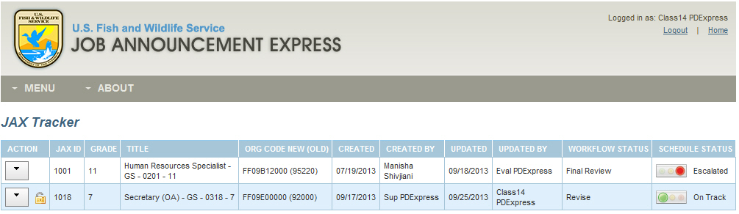

Additionally, the MY TRACKER dashboard has a Schedule Status header that indicates whether the current job announcement is on track regarding the workflow and time limits imposed on each different status within the workflow.

**ON TRACK**….

The **Schedule** indicates whether the job announcement is being addressed on-schedule.

## Schedule Status

This column provides the current schedule timing relative to workflow. It can be either **On Track**, **Warning**, or **Escalated**.

The chart below details the action that must be taken during each of these statuses (DRAFT, REVIEW, REVISE, FINAL REVIEW), and how many days each role (HR, HM) has to complete the work that needs to be done to move the job announcement to next status.



Note, that when the job announcement is in FINAL REVIEW, it is your job, as an HR professional, to complete a final review of the job announcement, certify that the information is correct, and publish the job announcement for integration into USAStaffing/USAJobs. Only once this action is completed can the package be transmitted for posting so that qualified and interested candidates can apply for the position, answer the questions that were created in the Job Questionnaire, and be screened as “Best Qualified” “Well Qualified” or “Qualified” candidates for the position.

Note that **HR must sign the package at the end of FINAL REVIEW.**  This indicates that you have thoroughly reviewed the job announcement, and concur that it is correct and ready to be posted on USAStaffing/USAJobs.

# What Human Resource Must Do During REVIEW

Although Hiring Managers will typically create the Job Announcement Packages in JAX, HR also has the authority to create the job announcements in the same manner that HMs do. However, when creating job announcements, or when reviewing the packages created by HMs during the REVIEW phase, HR has a few additional options that HMs don’t have. For instance, when creating a job announcement, the HM creates the Job Analysis and then the Job Questionnaire. However, their work in the Job Questionnaire section starts with the KSA screen. As an HR professional, you are responsible for adding any qualifications (e.g., Minimum Qualifications, Basic Education Requirements, etc.) on the Job Questionnaire that are applicable to the job announcement. The system directs you to the Qualification screen as part of the workflow. This action may either happen in Draft if HR is creating the package or in Review if HM creates the package.

## Creating a NEW Job Announcement: Complete the Qualifications Screen

After completing the Job Analysis, the next step toward completing a new job announcement for Hiring Managers, is to associate Task Statements to each Final KSA on the KSA screen of the Job Questionnaire. However, HR has the added requirement to create the Job Qualifications (i.e., Minimum Qualifications, Basic Education Requirements, etc.) and associate questions to each. This can be done during the HR Review phase of Job Announcement development (if the HM is creating the announcement and submitting to HR for review) or during the draft process of creating a Job Announcement (if HR is creating the announcement). To get started on the Job Questionnaire, you’ll login to JAX, choose the job announcement from the MY TRACKER dashboard, and click EDIT.

It is important to note Selective Factor and Condition of Employment qualifications cannot be added on the Qualifications screen. All Selective Factors must be added and associated with a duty on the Job Analysis and these will be brought over to the Qualification tab of the Job Questionnaire from there. Conditions of Employment from the PD will be brought over to the Job Analysis and the Qualification tab of the Job Questionnaire so that HR can add questions (or qualification statements) for these. Conditions of Employment cannot be added in JAX, they can only be added to JAX through the PD.

### Complete the Qualifications Screen

1. **Login to JAX**
2. **Choose the Job Announcement from the MY TRACKER dashboard**
3. **Click EDIT**
4. **Click the JOB QUESTIONNAIRE header,** and the Qualifications screen will appear.

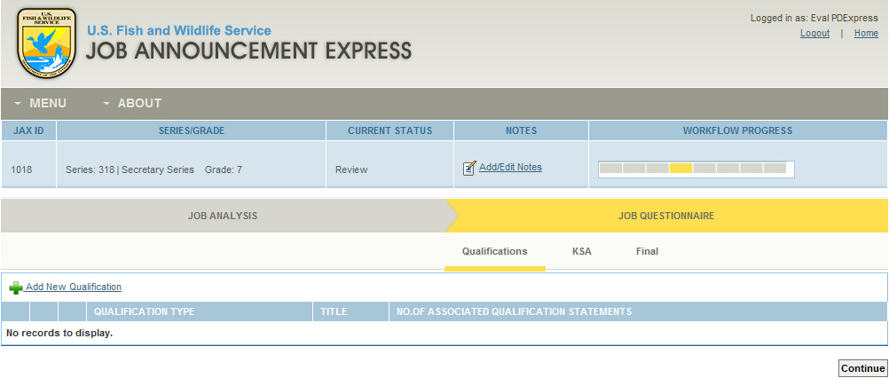

You will notice that the screen is blank. To add qualifications

1. **Click the ADD NEW QUALIFICATIONS link.** The Qualification Selection screen appears. Note: If the Job Analysis has Selective Factors or Conditions of Employment (from the PD) these will be automatically transferred from the Job Analysis to the Job Questionnaire.

**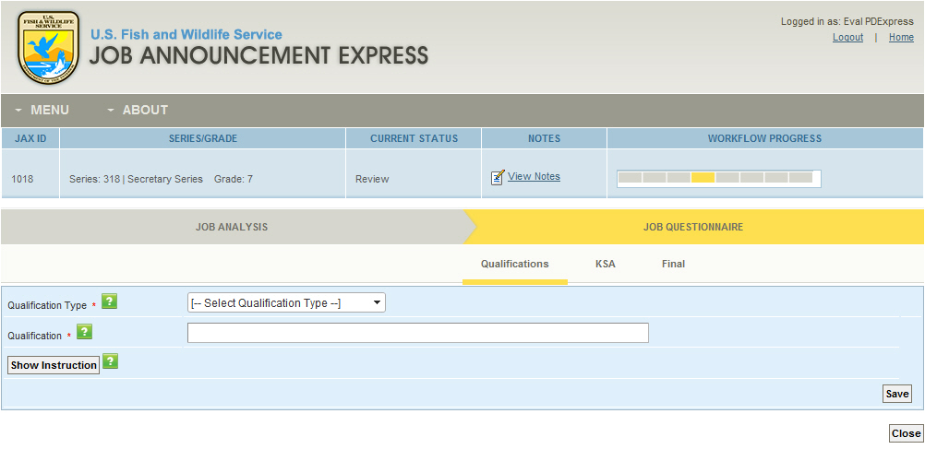**

1. From the provided drop down, **choose the QUALIFICATION TYPE** that you would like to add (NOTE: Items like Minimum Qualifications and Basic Education Requirements can be added directly on this screen. Selective Factors and Conditions of Employment show up on this screen, but cannot be edited. Selective Factors can only be edited on the Job Analysis, and Conditions of Employment are transferred from the PD.)

If you choose the MINIMUM QUALIFICATIONS item, a link will appear on the right, titled MINIMUM QUALIFICATIONS. These are the OPM Minimum Qualifications for the Series and Grade of the Announcement, and can be copied and included as Qualification Statements. Copy these minimum qualifications using the CTRL+C function. Then, click CLOSE to close the popup window.

1. The qualification instruction will default to say the same thing as the qualification type. For example, if you add Basic Education Requirements, the qualification instruction will default to say Basic Education Requirements. You should modify this to add more specific details about the qualification instructions for candidates applying for this position. (Note that HMs do not have access to modify instructions).
2. **Click SAVE to save the selection of Minimum Qualifications.**

The QUALIFICATION STATEMENTS screen will appear where you will add qualification statements.

1. **Click the ADD NEW QUALIFICATION STATEMENT link**. The Qualification Screen will appear.

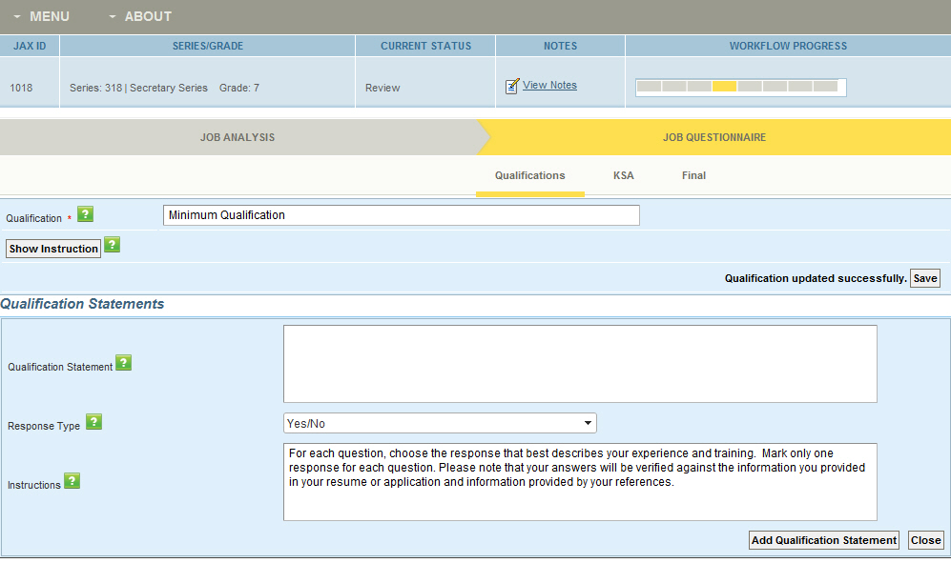

Here, you will enter the qualification statements (or questions that will be used on the Job Questionnaire) to support the qualification type that you chose.

1. **In the QUALIFICATION STATEMENT text entry box, type in the qualification statement** (or question to be posted on the Job Questionnaire) to support the qualification type. NOTE: If you copied the OPM Minimum Qualifications previously, you can use the JAX CTRL+V (paste) function to paste that copied text here.
2. **Review the Response Type and Instructions, and edit as necessary** (this is only relevant for Custom response types, as the default instructions cannot be modified). Note that HMs do not have access to modify response type or response instructions).
3. **Click ADD QUALIFICATION STATEMENT**.
4. **Repeat** until you have added all necessary QUALIFICATION STATEMENTS.
5. **Click CLOSE**.

This will return you to the QUALIFICATIONS screen, and will show you the Qualification type that you chose, and the number of Qualification Statements that you added to that Qualification.

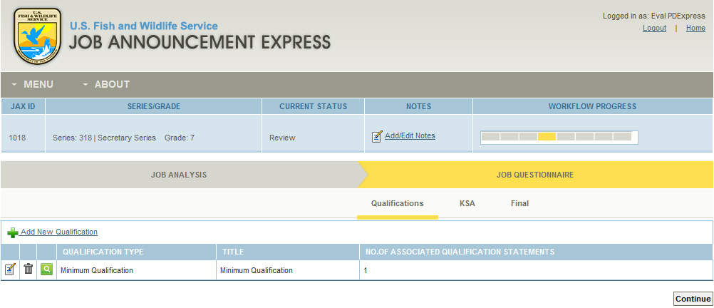

1. If you are finished adding Qualifications and Qualifications Statements, **click CONTINUE, otherwise click Add New Qualification and continue to add qualifications and associated qualification statements until you are done**.

Once this is done, you can continue creating/reviewing the job announcement (depending upon whether you are creating the announcement in DRAFT, or reviewing it for an HM during the REVIEW phase.)

## Modifying Job Questionnaire KSA Screen Instructions and Response Scales

Another task that HR is required to complete or revise , which HMs do not have access to, is the modification of instructions and response scales in the Job Questionnaire screens to tailor the questionnaire as desired. Specifically, on the Job Questionnaire KSA screen, there are KSA Instructions and Task Statements (questions that get asked of potential candidates to determine their qualifications for the position). These KSA instructions default to the text of the KSA. HR can modify these as needed to provide instruction to the candidate on how to respond. HR will also review the task statements created by the HM. These task statements can be either existing Task Statements (e.g. a question that has been previously asked for this KSA), or newly created Task Statements for this KSA (e.g. a question that is not already available on the prepopulated list.) In both cases, when an HM creates the job announcement, these task statements default to a response type of Multiple Choice. HR can also modify the response type and the response instruction (if a custom response type is selected). Only you, as an HR Professional can modify these instructions and response types.

### To Modify KSA Task Statement Question Types:

1. **Login to JAX**
2. **Choose the Job Announcement from the MY TRACKER dashboard**
3. **Click EDIT**
4. **Click the JOB QUESTIONNAIRE header,** and the Qualifications screen will appear.
5. **Click on the KSA screen link**
6. **Review the Final KSAs that have come over from the Job Analysis** (note that these are not editable here. Instead, you’ll have to go to the Job Analysis to make any necessary changes to the KSAs. Those changes will then be reflected on this JQ KSA screen upon your return.)
7. The KSA instructions will default to reflect the same language as in the KSA. You can edit this as necessary to provide more detailed instructions.
8. **Click the EDIT icon to the left of the first KSA**

Here you will see the Task Statements associated with the KSA – including the question type for each KSA.

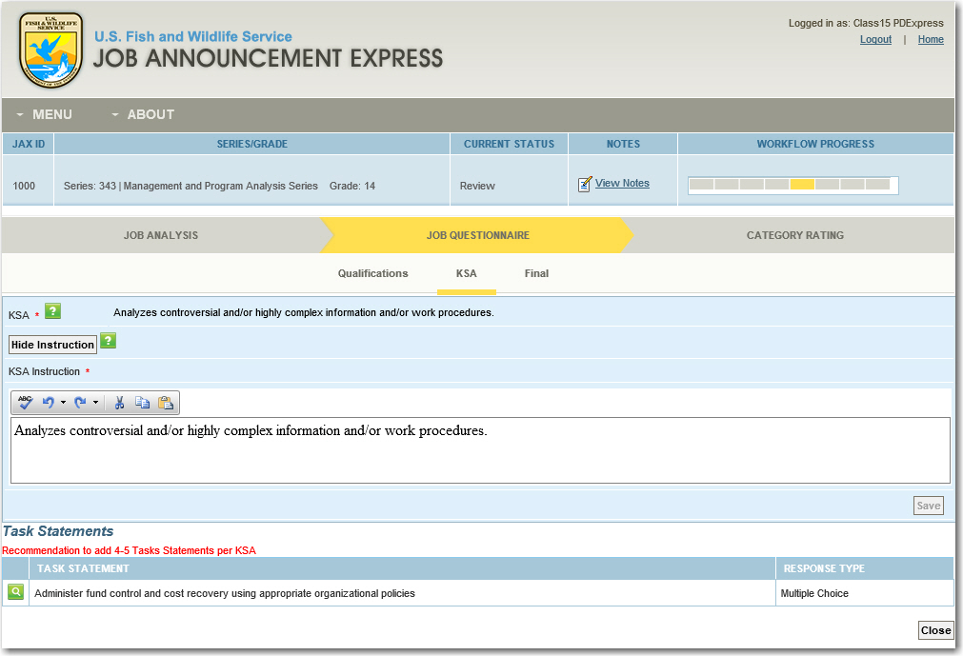

If you wish to review the Task Statement, and/or change the question type,

1. **Review the Task Statements that are associated to each KSA**.
2. **Click on the EDIT icon to the left of the first Task Statement**
3. The Task Statement screen will appear, where you can edit the wording of the task statement as necessary.
4. Click on the dropdown for the Response Type for the task statement. **Click the dropdown arrow to the right of the Response Type to change it.** Note that if you change the response type, you will have to review /edit (if necessary) the answers as well.

**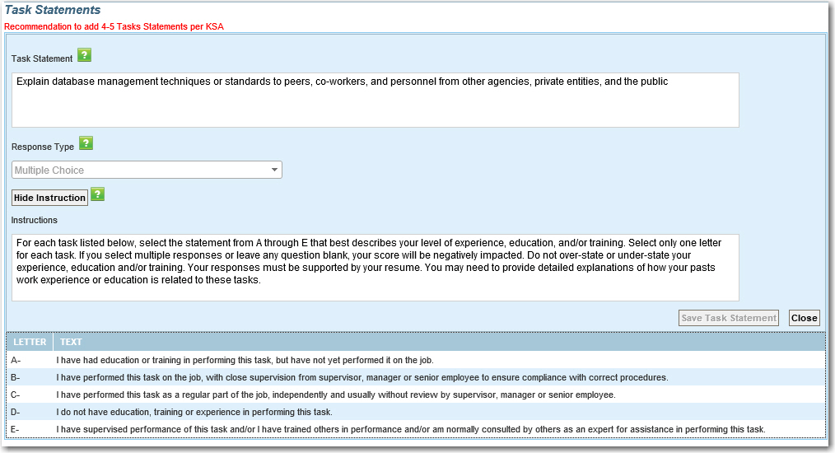**

1. **Review the Response Instruction, and edit if necessary.**  Note that you can only modify the response instruction if the response scale selected is Custom Yes/No or Custom Multiple Choice; otherwise the response instruction is not editable.
2. **Click SAVE TASK STATEMENT**, and then **Click CLOSE**

The KSA screen will appear, and you will see the revised question type for each KSA.

**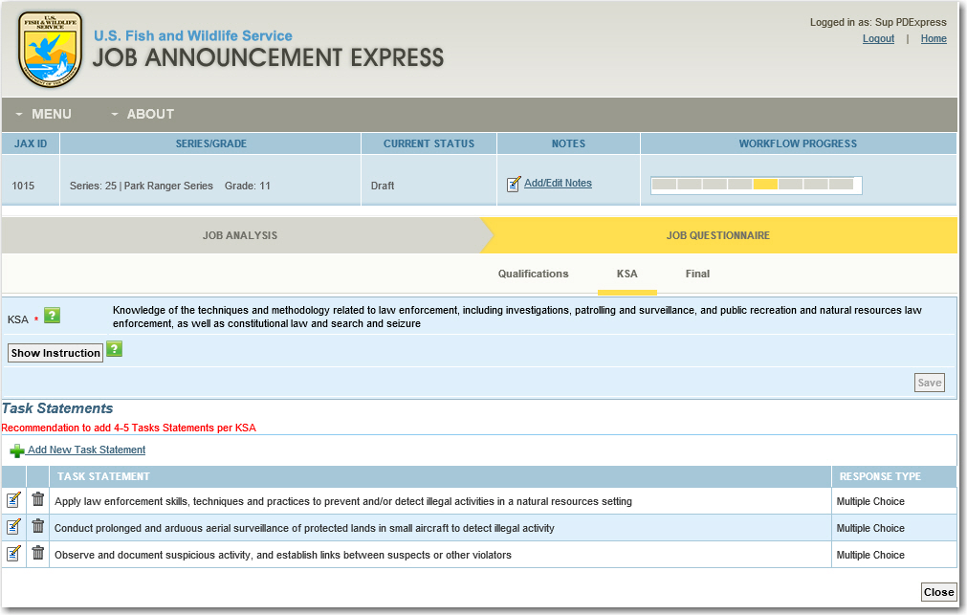**

Once this is done, you can continue creating/reviewing the job announcement (depending upon whether you are creating the announcement in DRAFT, or reviewing it for an HM during the REVIEW phase.)

## Reviewing and Modifying the order of FINAL Job Qualifications

Another task that HR can complete, which HMs do not have access to, is the modification of the order in which the Job Qualifications are listed on the Job Questionnaire. The system assumes that the first item in the list is the top priority, or most important job qualification for the potential candidates. Therefore, it is important as an HR Professional, that you review and edit this order if necessary. Only you, as an HR Professional can modify the order of these qualifications/questions as they appear on the Job Questionnaire.

## To Review the FINAL Job Qualifications:

1. **Login to JAX**
2. **Choose the Job Announcement from the MY TRACKER dashboard**
3. **Click EDIT**
4. **Click the JOB QUESTIONNAIRE header,** and the Qualifications screen will appear.
5. **Click on the FINAL screen link**

Here you will see the Job Questionnaire factors, ordered in their default order as the announcement was created. As an HR Professional, you will need to review each of the FINAL Job Factors to ensure that the order of the factors and corresponding task statements/questions and qualification statements associated to each item are appropriate, and reorder them if necessary. To do so:

**ON TRACK**….

You can preview the questions to see how they will appear on the UTF-8 by selecting the PREVIEW REPORT functionality. Doing so can help you decide whether the questions should be reordered.

**Review the order of the Factors,** and reorder as necessary**.**

**Click on the first FACTOR TITLE link.**

**Review the order of the Task Statements** and reorder as necessary.

**Click on SAVE ORDER**

**Click into the first Task Statement.**

Continue to review and reorder the Responses/Response Types for each Task Statement as necessary.

### To Modify the Order of the FINAL Job Qualifications:

1. **Login to JAX**
2. **Choose the Job Announcement from the MY TRACKER dashboard**
3. **Click EDIT**
4. **Click the JOB QUESTIONNAIRE header,** and the Qualifications screen will appear.
5. **Click on the FINAL screen link**

Here you will see the Job Questionnaire factors, ordered in their default order as the announcement was created. HR can reorder these factors (either because they aren’t in the correct order, or because the HM left a note asking for the factors to be reordered) by dragging and dropping each item so that they appear in the order you would like them displayed. HR should also review the top level factors individually to ensure that the questions associated with each factor are ordered properly. Once this is done, select Save Order and the system will renumber each item to reflect the newly saved order.

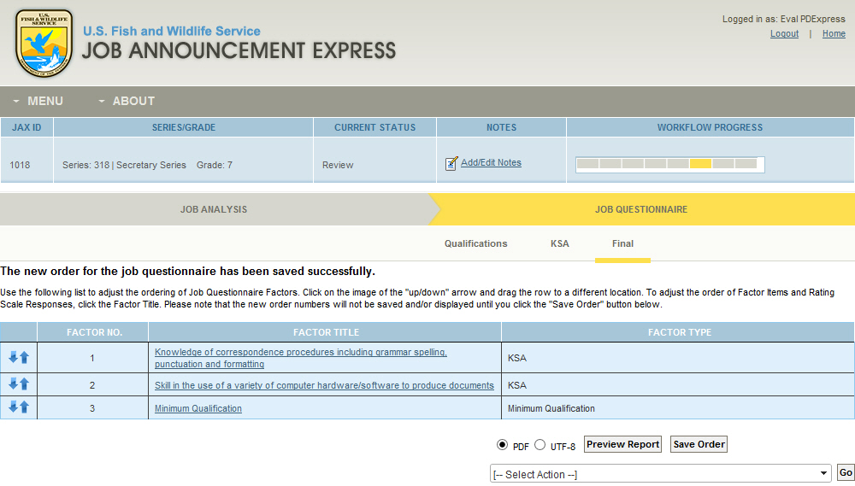

1. **Click the arrow to the left of the factor that you wish to move, and drag the factor to move it either up or down.**
2. **Continue with the remaining factors until all are in the correct order.**
3. **Click SAVE ORDER**
4. **Click the first factor** to open the factor.
5. **Review the questions associated with the factor to ensure that they are in the appropriate order.**
6. **Reorder the questions as you see necessary.**
7. **Click SAVE ORDER.**
8. **Continue reviewing the questions associated with each factor until all are in the correct order.**

Once this is done, you can continue creating/reviewing the job announcement (depending upon whether you are creating the announcement in DRAFT, or reviewing it for an HM during the REVIEW phase.)

# What Human Resource Must Do During FINAL REVIEW

Regardless of whether the job announcement was created by an HM or by HR, HR has specific steps that must be taken during the FINAL REVIEW phase of the job announcement creation workflow. During this phase, it is your job, as an HR professional, to complete a final review of the job announcement, certify that the information is correct, and publish the job announcement for integration into USAStaffing/USAJobs. Only once this action is completed can the package be transmitted for posting so that qualified and interested candidates can apply for the position, answer the questions that were created in the Job Questionnaire, and be screened as “Best Qualified” “Well Qualified” or “Qualified” candidates for the position.

Note that **you are required to sign the package at the end of FINAL REVIEW prior to publishing the package.**  This indicates that you have thoroughly reviewed the job announcement, and concur that it is correct and ready to be posted on USAStaffing/USAJobs.

## Completing the FINAL REVIEW

**ON TRACK….**

Note that during REVISE, the Hiring Manager can edit all sections of the job announcement (including the questions on the qualifications tab which HR created during the REVIEW phase), except for the HR only sections (e.g. HMs cannot make edits to JQ factor instructions, modify the response scale selections for JQ questions and/or modify the response scale instructions on the JQ [this is true for both the Qual and KSA tab of the JQ] and they cannot re-order questions on the Final screen of the JQ).

After completing the REVIEW and adding the Job Qualifications, editing the necessary HR fields, and adding suggestions for HM revisions, the job announcement is returned to the Hiring Manager (or whomever drafted the job announcement) for final edits and signature. The Hiring Manager (or whomever drafted the job announcement) will then sign the package and return it to HR for final review and publishing.

During FINAL REVIEW, you can make edits ONLY to the HR-only sections. This is because the HM has already signed off on the announcement, therefore the main content of the job announcement is off limits, and you can only make final updates to HR-only sections prior to finalizing and posting the announcement.

Once you have finalized the announcement (in other words, you have completed your FINAL REVIEW, and have edited anything that requires edit), you must sign and publish the job announcement package. To do so, in the dropdown at the bottom of the screen, once the job announcement is signed by the HM and by HR, choose the “Check and publish” link.

Doing so will force a final validation of all required fields (and signatures) and force the HR signature if one has not yet been completed prior to publishing. To publish the final announcement:

1. **Select the *Sign As* radio button for HR Personnel**
2. **Enter your Title** (e.g. Staffing Specialist, etc.)
3. **Enter your password**
4. **Click the SIGN button**
5. **From the *Select Action* dropdown, select CHECK AND PUBLISH**
6. **Click GO** to publish the package

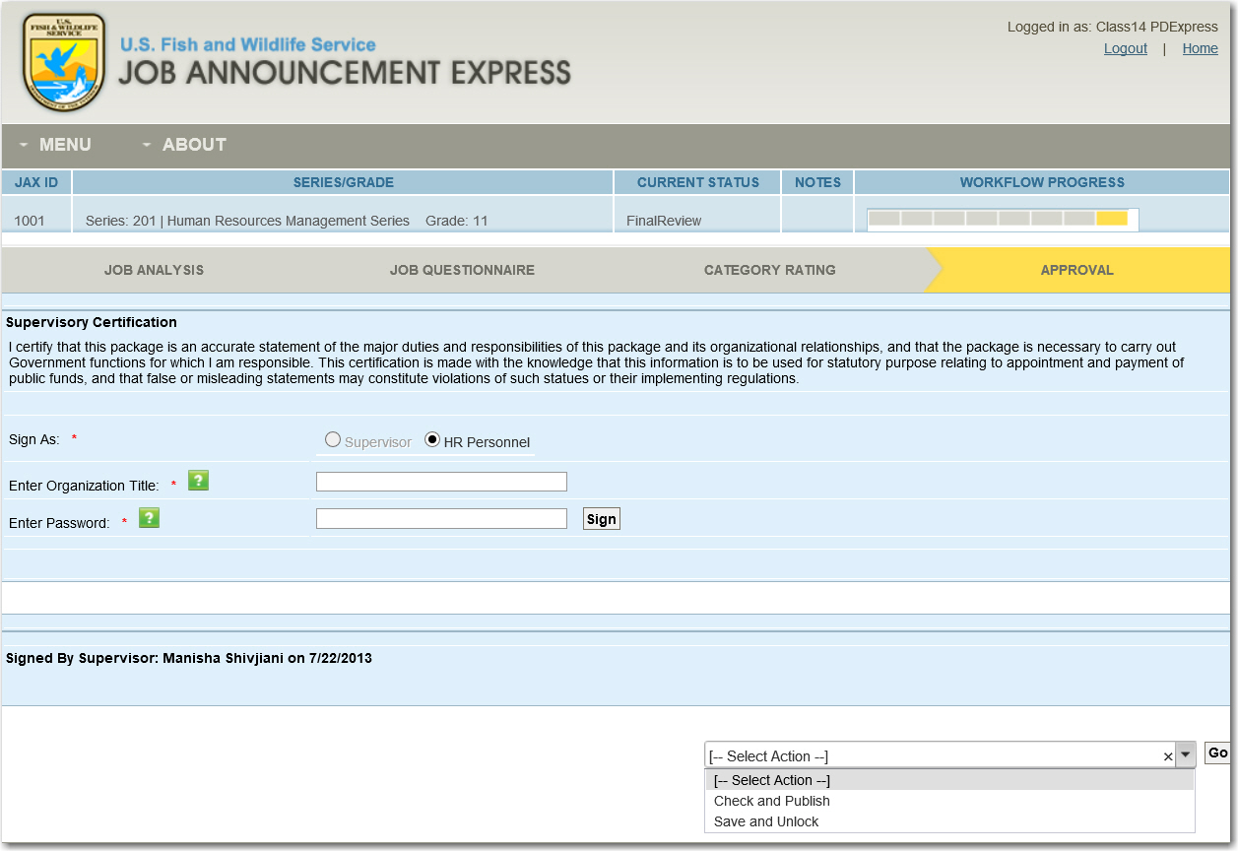

## Extracting the UTF-8 Formatted Job Questionnaire

Once the package has been signed by both the HM and HR, it will disappear from your MY TRACKER dashboard. To return to the package and extract the UTF-8 formatted job questionnaire (so that it can be uploaded to USAStaffing) follow these steps:

1. **Login to JAX**
2. **Click on MENU and choose SEARCH from the dropdown**
3. **Type the JAX ID into the text entry box, and click SEARCH**
4. The job announcement will appear in the SEARCH RESULTS area.
5. **Click on the dropdown under DOCUMENT, and choose Job Questionnaire UTF-8**

**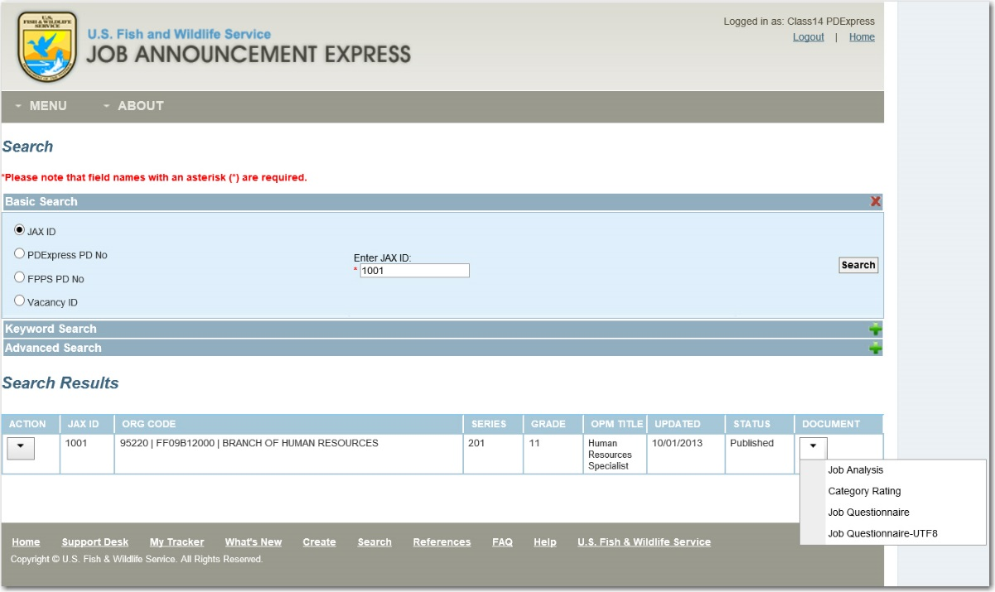**

Here you will be directed to a standard Windows dialogue box, and asked if you want to OPEN, SAVE, or CANCEL. **Choose OPEN to open the UTF-8 version of the document**. (Note: Managers do not have access to the Job Questionnaire in the UTF-8 file format, they have access to a PDF format only.)

Once opened, **SAVE the UTF-8 version of the document** in a location on your computer where you can easily find it so that you can send it to USA STAFFING for upload.

Before uploading the UTF-8 file to USA Staffing make sure the text file is saved as UTF-8. This can be done by selecting Save As in the Text File and selecting UTF-8 in the drop down

# What Human Resource Must Do after the Job Announcement is Published

After the job announcement is published and imported into USA STAFFING, and the posting the announcement is listed on USA JOBS, you will hopefully be able to fill the vacancy with a qualified candidate. Regardless of whether the position is filled or not, you should return to the JAX module and update the hiring results for the job announcement. Updating the hiring results will help future HMs and HR personnel determine whether the job announcement resulted in a successful hire for the position, and therefore whether when creating a new job announcement, this particular record might be a good one on which to base the creation of their new record.

## Updating the Hiring Results for a Published Job Announcement

Once a job announcement is published in JAX, HR has the ability to update the results of the announcement – in other words, to indicate whether the announcement resulted in the successful hiring of a candidate into the Service. To do so:

1. **Click on MENU and choose SEARCH from the dropdown**
2. **Type the JAX ID into the text entry box, and click SEARCH**
3. The job announcement will appear in the SEARCH RESULTS area.
4. **Click on the dropdown under ACTION, and choose Update Hiring Results**

**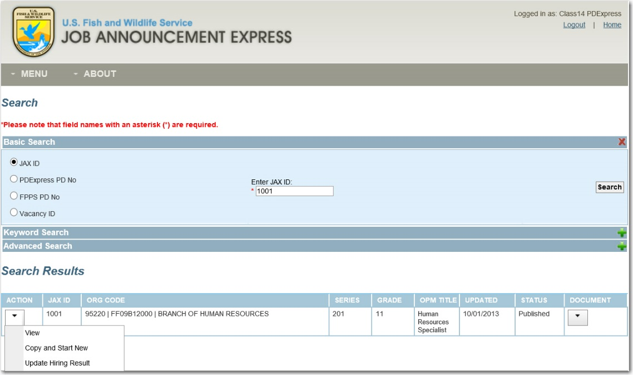**

1. A popup window will appear in which you can indicate whether a candidate was **successfully hired for the position, and post the vacancy ID for the announcement. Fill Out this popup and then click Update Hiring Result**.

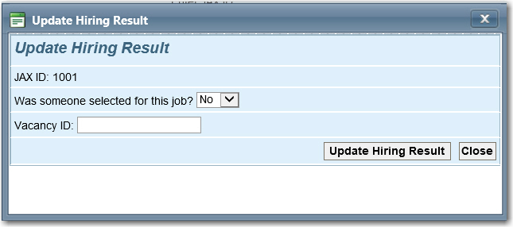

# Additional Actions that HR can take on the Job Announcement

Aside from the actions that HR MUST take during REVIEW and FINAL REVIEW of the job announcement, there are additional actions that HR can take on the job announcement, depending upon the individual circumstances.

## Adding NET NEW KSAs/Task Statements to the Library for the Series

Once HR receives the job announcement in Revise, they have the ability to search from a list of standard KSAs and add KSAs for the selected Series and Grade that may have initially been missed by the creator. Similar to creator, if HR determines that none of the KSAs in the library are adequate for their job announcement, they can select CREATE NEW and create net new KSAs for their job announcement.



Likewise, HR has the capability to add Task Statements (or questions that are asked of the potential applicants) that the Hiring Manager or Creator may have missed when drafting the package. Similar to KSAs, HR can either add new KSAs from the list of standard Task Statements associated with the KSA or create a net new Task Statement by selecting CREATE NEW. Any net new Task Statements added by Hiring Managers to the package MUST be reviewed by HR during REVIEW to ensure that they meet the requirements for the position. Additionally, as HR you can add these net new Task Statements to the library of for the series.



When the net new Task Statement is added to JAX by the creator of the job announcement, HCMS checks the task statement after it has been created and saved to determine whether the task statement already exists in the JAX library. If the task statement does not already exist you will see a link that says "Add to Library" next to the Task Statement when you access the new Task Statement.

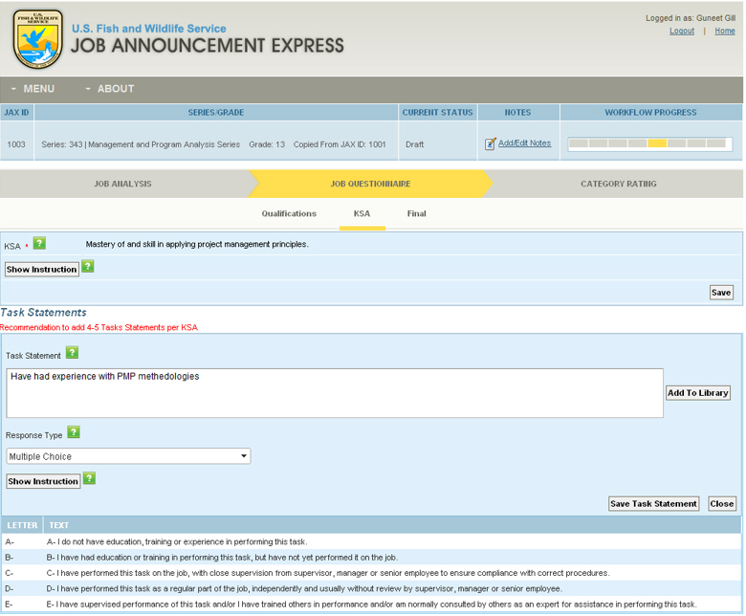

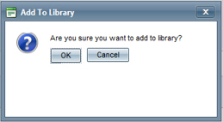Click the “Add to Library” link, and the system will provide a warning message.

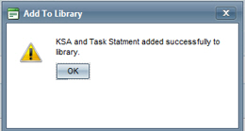

Select OK and user is provided with the message that the Task Statement has been added.

After the new KSA and/or Task Statements are added to the library, whenever a manager (or another HR Professional) begins the process of creating a job announcement of the same Series / Grade, the new KSA /Task Statement will be available for use in the new job announcement package from the standard lists.



##### MODULE 5: ADMIN FUNCTIONS IN JAX

##### (ADMIN)

Module 5: ADMIN Functions in JAX (ADMIN)

Administrator, or Admin roles within JAX are responsible for additional functionality in the system, including user account maintenance, and activation/inactivation of job announcements. There are two levels of JAX Administrators: Regional Administrators and System Administrators. While the responsibility is similar around Regional and System Admin roles, there are a few key differences in access. Specifically, Regional Administrators can perform all functions that HMs can within the Region to which they have access, but cannot sign in as HR or Supervisor. System Administrators, on the other hand, can perform all roles within all regions, regardless of the organization code or status of packages. Below are some of the details of what Administrators can do within the JAX system, based on the workflow:

|  |  |
| --- | --- |
| **DRAFT STATUS** | |
| System Admin | * Can access and make edits to all sections of all packages in all Regions from My Tracker and Search. * Can *Finish Edit* when Package is in Draft by the HM via Search & My Tracker |
| Regional Admin | * Can access and make edits to all sections of all packages in their Regions from My Tracker and Search. * Can *Finish Edit* when Package is in Draft by the HM via Search & My Tracker |
| **REVIEW STATUS** | |
| System Admin | * Can access and make edits to all sections of all packages in all Regions from My Tracker and Search. * Can *Finish Edit* when Package is in Review by HR via Search & My Tracker |
| Regional Admin | * Can access and make edits to all sections of all packages in their Regions from My Tracker and Search. * Can *Finish Edit* when Package is in Draft by HR via Search & My Tracker |
| **REVISE STATUS** | |
| System Admin | * Can access and make edits to all sections of all packages in all Regions from My Tracker and Search. * Can *Finish Edit* when Package is in Revise by HM via Search & My Tracker |
| Regional Admin | * Can access and make edits to all sections of all packages in their Regions from My Tracker and Search. * Can *Finish Edit* when Package is in Revise by HM via Search & My Tracker |
| **FINAL REVIEW** | |
| System Admin | * Can access and make edits to all sections of all packages in all Regions from My Tracker and Search. * Can *Finish Edit* when Package is in Final Review by HR via Search & My Tracker |
| Regional Admin | * Can access and make edits to all sections of all packages in their Regions from My Tracker and Search. * Can *Finish Edit* when Package is in Final Review by HR via Search & My Tracker |

Administrators also have the ability to add new users, edit users, and inactivate users. However, all users must have an active directory accounts in order to be able to be added to the JAX module.

**System Administrator:** The System Administrator activates/inactivates, and modifies user accounts for the entire Agency. The role also allows the System Admin to maintain HCMS tables and to create announcements across the Agency. The System Admin can also complete the Hiring Manager and Human Resources functions in HCMS across the Agency.

**Regional Administrator:** The Regional Administrator activates/inactivates, and modifies user accounts for their entire Region. The role also allows the Regional Admin to maintain Region table(s) and to create announcements across their Region. The Regional Admin can also complete the Hiring Manager, and Human Resources functions for their Region.

# ****Administration Tab in HCMS****

To log in as an Administrator, you can use the HCMS portal. Your JAX login is synchronized with your Active Directory network account, and your access level based on your status within the system (Regional or System Administrator).

As an administrator, once you have logged in to The Human Capital Management System (HCMS) you will see a tab titled “Administration”. This tab is a web-based tool that enables FWS Regional and System Administrators to administer access to both PD Express and the JAX system. This includes administration of user accounts (assigning / modifying roles, etc.), activating and delegating ownership of Position Descriptions and Job Announcements, Organization Code administration, and adding/editing KSAs and Task Statements.

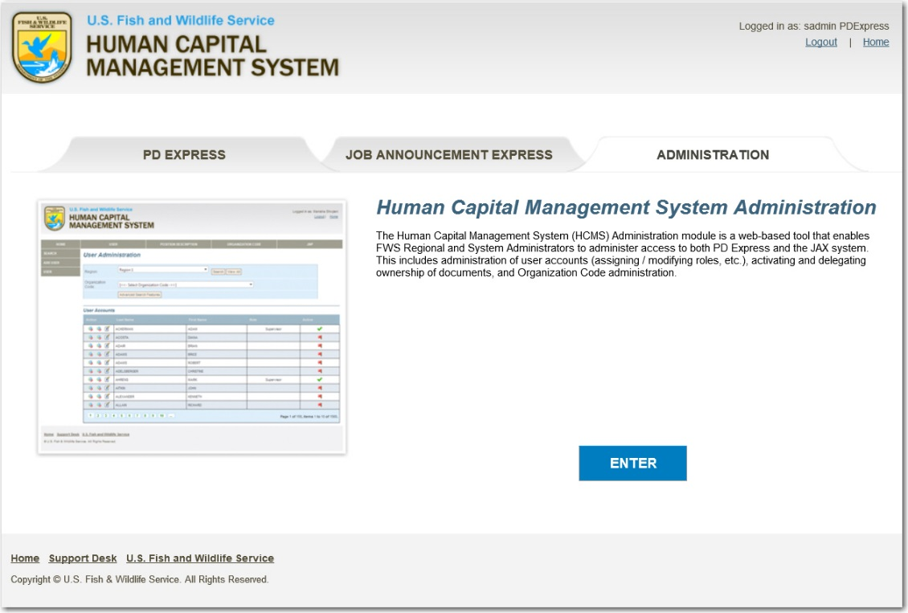

Once you have logged in and accessed the Administration tool, you will see tabs at the top and left. The tabs at the left are the primary level tabs, and those at the top are the filters for the left tabs. For instance, if you choose the SEARCH tab at the left, you can then determine, using the tabs at the top, if you want to search for a User, for a PD, for organization codes, or for job announcements in JAX. We’ll detail the two left menu items taH below:

SEARCH: Allows you to Search using the tabs across the top. You can search by User, Position Description, Organization Code, or within JAX. We’ll cover each of these in more detail.

ADD USER: Allows you to add a brand new user to the HCMS system (both PD Express and JAX).

# The SEARCH Function

As an Administrator, you can Search using the tabs at the top to filter what you are searching for. There are four tabs at the top for which you can search. These are: User, Position Description, Organization Code, and JAX. We will not cover the administrative information associated with the Position Description or Org Code administration, since that was covered previously in the PD Express training. Instead, we’ll focus on User Administration, and JAX Administration.

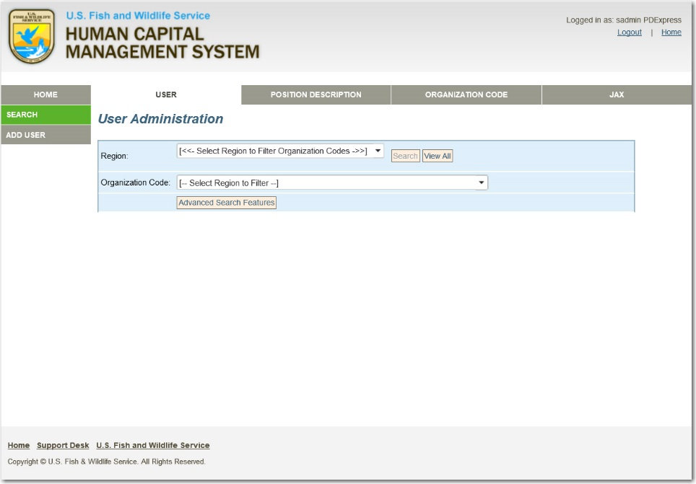

## When to Search by USER

As an Administrator, you will search for a User when you need to find all of PDs or Job Announcements that the user has created, or when you need to maintain the user’s account. When searching for a user, you will have to know both the Region and Org Code to which the user is assigned, or the user’s first and last name. Either of this information will allow you to search for the user, and return appropriate search results.

## To Search for a User Using the Region and Org Code:

1. **Click SEARCH on the left Menu**
2. **Choose the USER tab at the top**
3. **Choose the REGION that you wish to Search**
4. **Choose the ORG CODE within the Region**
5. **Click SEARCH**
6. Results will appear at the bottom of the screen.

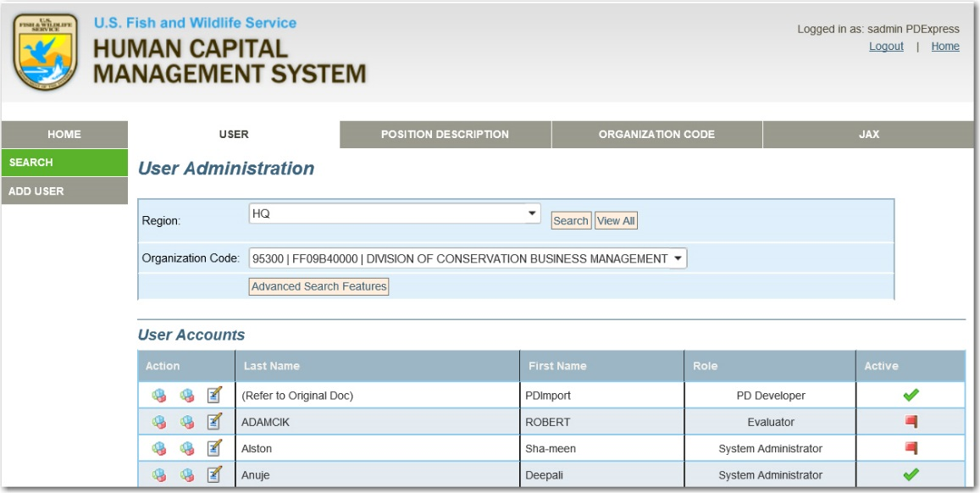

From here, you can use the icons to the left of the user to either View the PDs that have been drafted but are not yet published by the user; View the Job Announcements that have been drafted but are not yet published by the user; or edit the User’s information.

Viewing the unpublished PDs and Job Announcements is useful when the item has been escalated due to inaction within the allotted time for item. For instance, if there is a job announcement in REVISE phase, for which the user has not yet accessed, revised, and signed within the allotted 5 days, as the Administrator, you may need to take action on that Job Announcement. Additionally, you can delegate the PDs and Job Announcements to another user (if requested).

Editing the User’s information is useful for user account maintenance. As an administrator, you can activate, modify and inactive user accounts manually, although these types of updates are typically done on an ad hoc basis and are few in number. You can also assign Regions and Org Codes to users.

However, you cannot edit the user’s name, email address, and Supervisory Status ID as that information is synched with active directory, and thus is not editable.

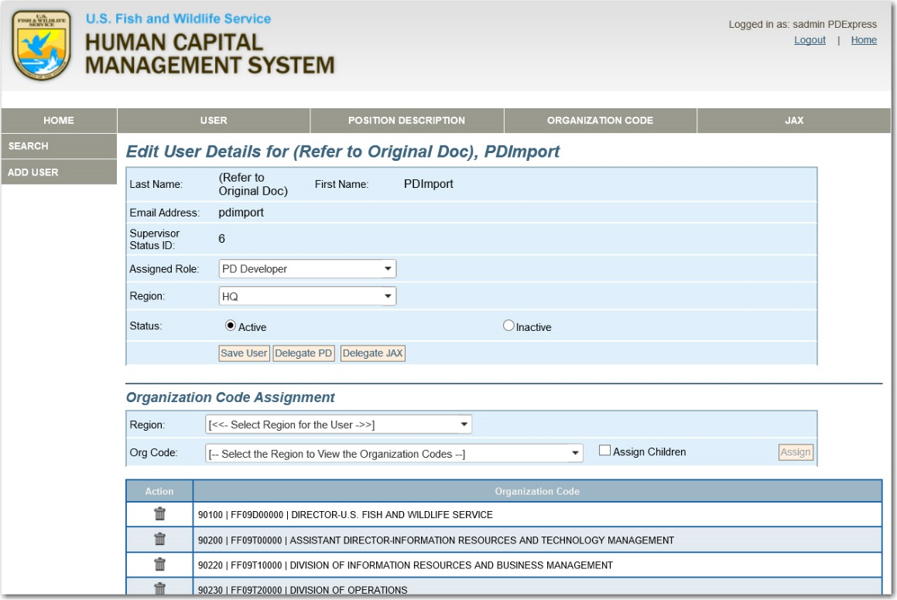

### Editing Assigned Role

You can edit a user’s assigned role and region in the HCMS system.

1. Use the drop down selections provided for the user, to **choose the revised Assigned Role and Region for the user**.
2. **Click the SAVE USER button** to save your revisions.

### Editing a User’s Status

You can edit a user’s status – either setting the user to inactive, or reactivating a user within HCMS from this page as well.

**HELP**

A user with PDs or Job Announcements in DRAFT, REVIEW, REVISE, or FINAL REVIEW cannot be inactivated.

Instead, you must work with the user to complete all active PDs and/or delegate PDs to an eligible user account before deactivating the user.

1. **Select the INACTIVE radio button**.
2. **Click the SAVE USER button** to save your revisions.

This will cancel the user’s access to the HCMS system (both PD Express and JAX) but will not delete the user from the system. Therefore, a user account can be reactivated if necessary.

1. **Select the ACTIVE radio button.**
2. **Click the SAVE USER button** to save your revisions.

### Adding Regions and Org Codes to a User

An Organization Code is the key to user access within both PD Express and JAX. Organization Codes drive a user’s ability to create, edit, and view job announcements. HCMS will automatically assign Org Codes based on the user’s FPPS org code when the account is first created. And, HCMS will add additional codes to the user if the FPPS data changes, but removal of invalid Org Codes are a manual process request to the Regional Administrator.

#### To Add an Org Code to a Specific User:

1. **Select the Region** from the dropdown.
2. **Select the ORG Code** from the dropdown.
3. **Click the ASSIGN button**.
4. Repeat these steps until the user has access to all necessary codes.

HCMS also allows the assignment of Org Codes via a parent/child structure. Clicking on the ASSIGN CHILDREN box next to the Org Code dropdown will update the user’s profile with the new Org Code and any child org codes associated with it.

#### To Remove an Org Code:

1. From the Action column to the left of Org Codes list, cli**ck on the delete icon to the left of the Org Code which you want to remove**.

# The ADD USER Function

The Add User function allows you to add a user to HCMS. The user must already have an Active Directory account, and you must know the user’s first and last name, or email address in order to search for the user from the Active Directory and add them to HCMS.

## To Add a User:

1. **Click the ADD USER link** on the left.
2. The SEARCH window will open.
3. **Enter the Users first and last name, or email address**.
4. **Click SEARCH**.
5. The ADD USER box will appear.
6. **Select the User’s name from the USER dropdown**.
7. **Select the user’s role from the ROLE dropdown**.
8. **Select the user’s region from the REGION dropdown**.
9. **Click the ADD USER button**.

If the user was added successfully, a note will display



# JAX Tab in HCMS

When you select the JAX tab on the horizontal header within the Admin Module, you’ll notice that the left menu changes from showing “SEARCH” and “ADD USER” – which are HCMS functions that impact both PD Express and JAX, to more JAX specific functions such as JAX, KSA, TASK STATEMENT, and SERIES/KSA TASK STATEMENT. Each of these allows you to administer those specific items within JAX. We’ll cover each in detail in the following information.

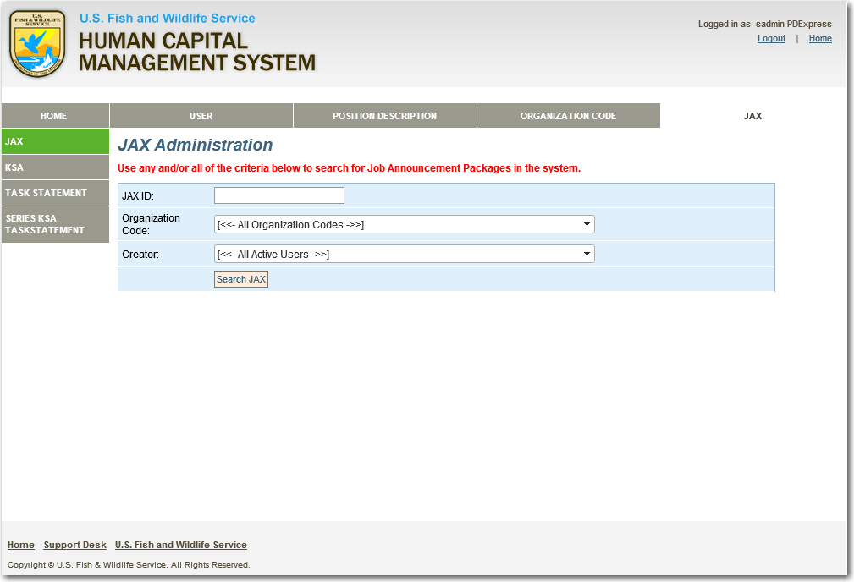

# JAX Administration: JAX Tab

The JAX tab on the left of the JAX Admin module allows you to search all job announcements using the JAX ID, Organization Code, or Creator. The search results will return all job announcements, regardless of status, created by the chosen individual. From there, you can choose to deactivate active job announcements, or reactivate inactive job announcements.

## Search for Job Announcements

1. **Click JAX on the left menu**.
2. **Enter the JAX announcement ID, or chose the Organization Code or Creator Name** from the dropdown lists.
3. **Click SEARCH JAX**
4. A list of job announcements that meets your search criteria will appear.
5. **Click the arrow in the Active/Inactive Column** to Activate or Deactivate the job announcement you wish to change.
6. You will see that a red flag appears next to inactive job announcements, and a green check appears next to the active job announcements.

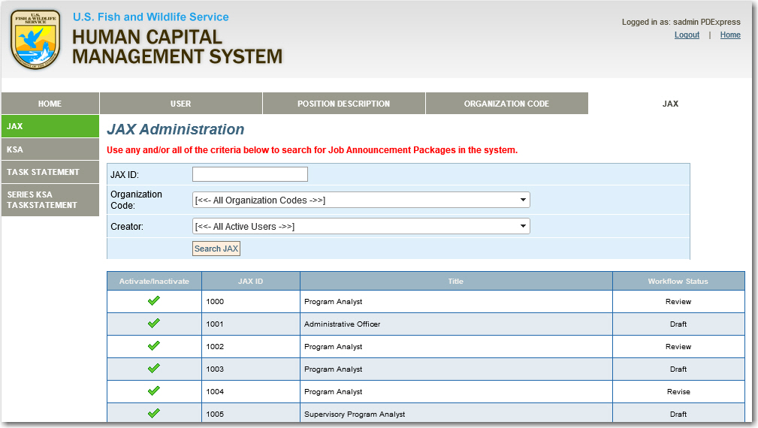

# JAX Administration: KSA Tab

The KSA tab allows administrators to view all KSAs (only those within the designated Region for Regional Admins), and activate/deactivate, and edit those KSAs.

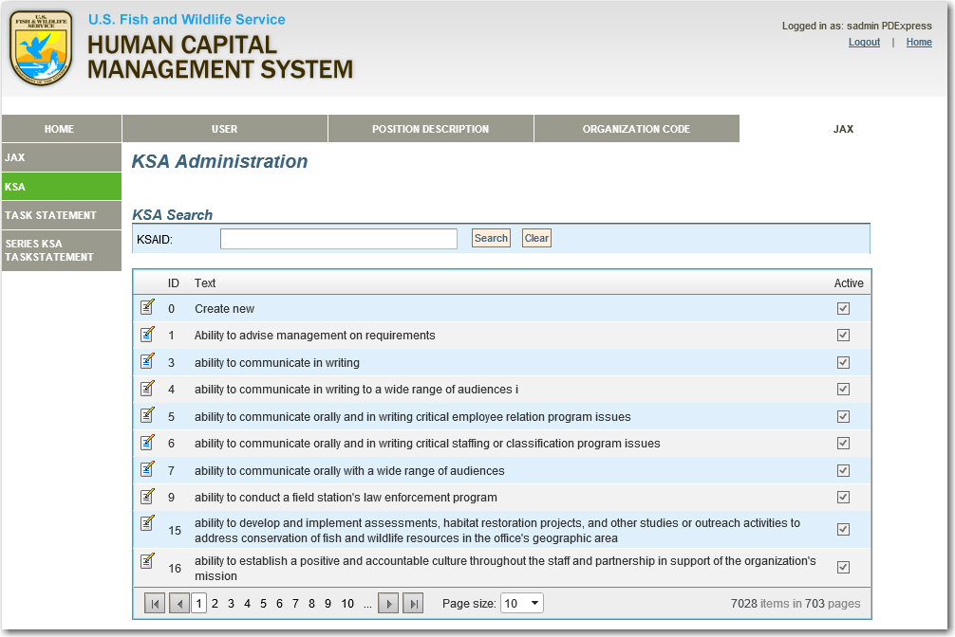

## JAX KSA Tab

1. **Click KSA on the left menu**.
2. The KSA Screen will appear with the full listing of all KSAs to which you have access, as well as an area in which you can search for specific KSAs.

### Search for Specific KSAs

1. **In the JAX KSA Tab, enter the KSA ID to search for the specific KSA**.
2. **Click SEARCH**.
3. The search results will return all items that match your search request.

### Edit Existing KSAs

**ON TRACK**….

Note when editing KSAs that the same KSA may be used across multiple grades within a single series, and across multiple series. Updates to a KSA will be reflected across all series/grades which use the given KSA.

1. **In the JAX KSA Tab, click on the EDIT icon** to the left of the KSA that you wish to edit.
2. **Edit the KSA text** as you see necessary.
3. **Or, Deactivate the KSA by clicking the checkbox next to ACTIVE**
4. **Click on the green check mark to save your changes**.
5. **Or, click on the red X to cancel your changes**.

# JAX Administration: Task Statement Tab

The Task Statement tab allows administrators to view all Task Statements (only those within the designated Org Codes for Regional Admins), and activate/deactivate, and edit those Task Statements.

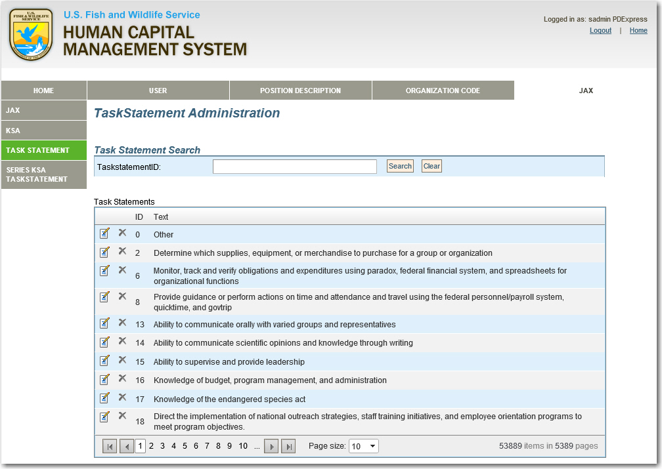

## JAX Task Statement Tab

1. **Click Task Statement on the left menu**.
2. The Task Statement Screen will appear with the full listing of all Task Statements to which you have access, as well as an area in which you can search for specific Task Statements.

### Search for Specific Task Statements

1. **In the JAX Task Statements Tab, enter the Task Statement ID to search for the specific Task Statements**.

**ON TRACK**….

Note when editing Task Statements, that the same Task Statement may be used across multiple KSAs within a series, and across multiple series. Updates to a Task Statement will be reflected across all series/grades which use the given Task Statement.

1. **Click SEARCH**.
2. The search results will return all items that match your search request.

### Edit Existing KSAs

1. **In the JAX Task Statement Tab, click on the EDIT icon** to the left of the Task Statement that you wish to edit.
2. **Edit the Task Statement text** as you see necessary.
3. **Or, Deactivate the Task Statement by clicking the checkbox next to ACTIVE.**
4. **Click on the green check mark to save your changes**.
5. **Or, click on the red X to cancel your changes**.

# JAX Administration: SERIES KSA TASK STATEMENT Tab

The Series KSA Task Statement Tab allows the System and Regional Administrators to administer KSAs and Task Statements that are assigned to a particular series and grade. This tab can be used to associate/disassociate already existing KSAs in HCMS to a series and grade or add a net new KSA to a series and grade

## Editing Existing KSAs and Task Statements

Existing KSAs and their associated Task Statements can be edited by System Administrators in HCMS, and existing Task Statements can be associated to existing KSAs to which they have not previously been associated.

### To Edit an Existing KSA

1. On the JAX Administration Tab, **select SERIES KSA TASK STATEMENT left menu item**.
2. **Select the appropriate Series from the SERIES drop down list**
3. **Choose the Grade from the GRADE drop down list**
4. You will be provided with all the list of existing KSAs within the selected Series and Grade

**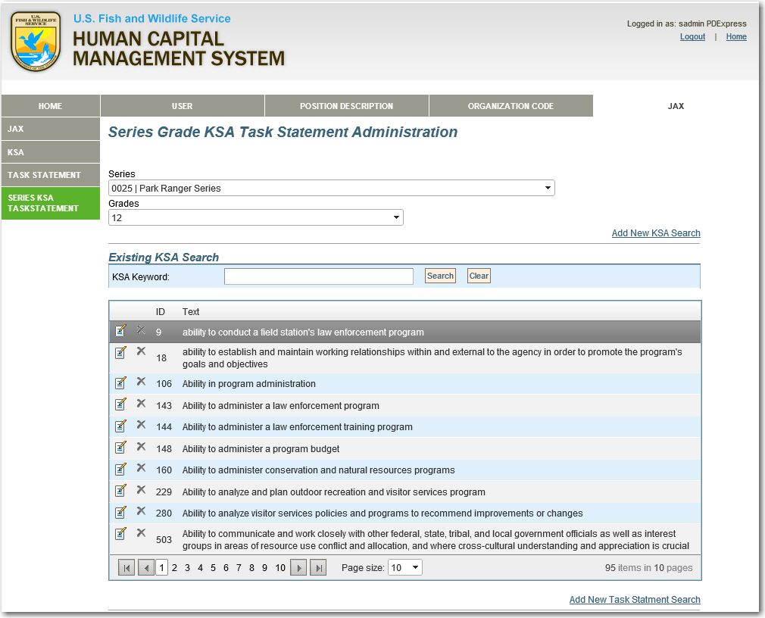**

1. **Select the KSA that you wish to edit** by clicking on the edit icon on the left of the chosen KSA.
2. The KSA text will appear in an editable box, to allow you to edit the text. **Edit the wording as necessary**.
3. Then, **click the green check mark to save your edits** to the existing KSA.

### To Edit Existing Task Statements

1. On the JAX Administration Tab, **select SERIES KSA TASK STATEMENT left menu item**.
2. **Select the appropriate Series from the SERIES drop down list**
3. **Choose the Grade from the GRADE drop down list**
4. You will be provided with all the list of existing Task Statements within the selected Series and Grade.
5. **Select the Task Statement that you wish to edit** by clicking on the edit icon to the left of the chosen Task Statement.
6. The Task Statement will appear in an editable box, to allow you to edit the text. **Edit the wording as necessary.**
7. Then, **click the green check mark to save your edits** to the existing Task Statement.

### 

Aside from editing existing KSAs and Task Statements, you can also edit existing KSAs by adding Task Statements which are in the HCMS library, but have never been associated with the Task Statement previously.

### To Add an Existing Task Statements to a previously unassociated KSA.

1. On the JAX Administration Tab, **select SERIES KSA TASK STATEMENT left menu item**.
2. **Select the Series and Grade to which you wish to add the new Task Statements.**
3. From the list of KSAs, **click on the KSA to which you wish to associate a new Task Statement**.
4. **Select the Add New Task Statement Search** link.
5. The Search Task Statement Screen will appear.

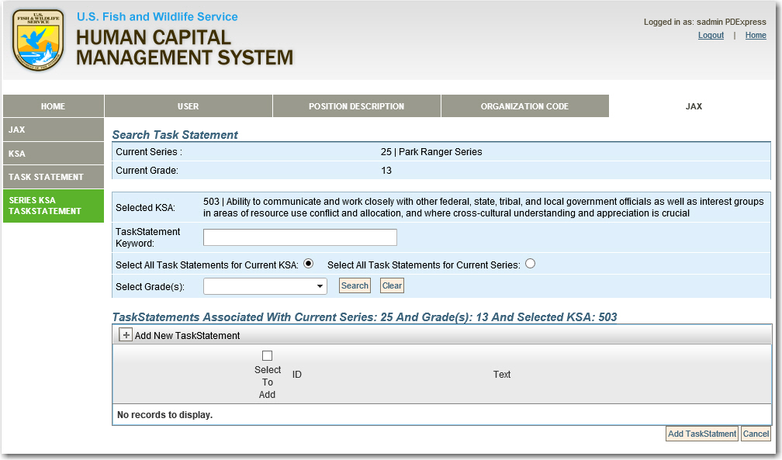

1. **Enter the Task Statement Keyword** on which you will search,
2. **Choose whether to search Task Statements for the Current KSA or All Task Statements for the Current Series**
3. **Select the Grade** in which you wish to search
4. **Click SEARCH**
5. A list of Task Statements that match your search criteria will appear.

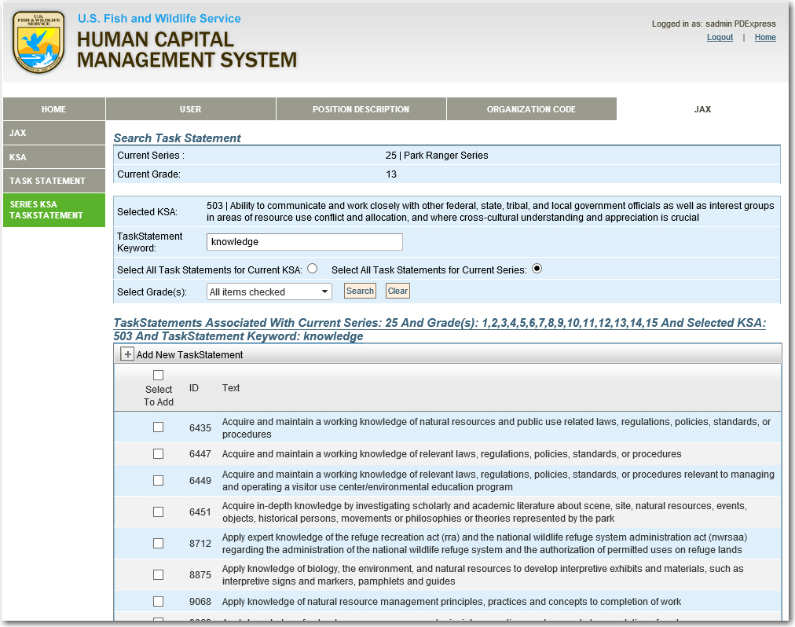

1. **Click the Select to Add** checkbox to the left of the Task Statement that you’d like to add to the KSA.
2. Continue doing so until you’ve added all applicable Task Statements.
3. **Click the ADD TASK STATEMENT Button** to return to the SERIES KSA TASK STATEMENT page, where the new Task Statement has been added to the KSA.

## Adding net new KSAs to HCMS

Another task that Administrators can complete in HCMS is to add completely new (not previously existing) KSAs to the system.

### To Add a New KSA to HCMS:

1. On the JAX Administration Tab, **select SERIES KSA TASK STATEMENT left menu item**.
2. **Select the Series and Grade for which you wish to add the new KSA.**
3. **Select ADD NEW** **KSA** **SEARCH**
4. On this screen **Click the Green Plus mark to expand the ADD NET NEW KSA section**

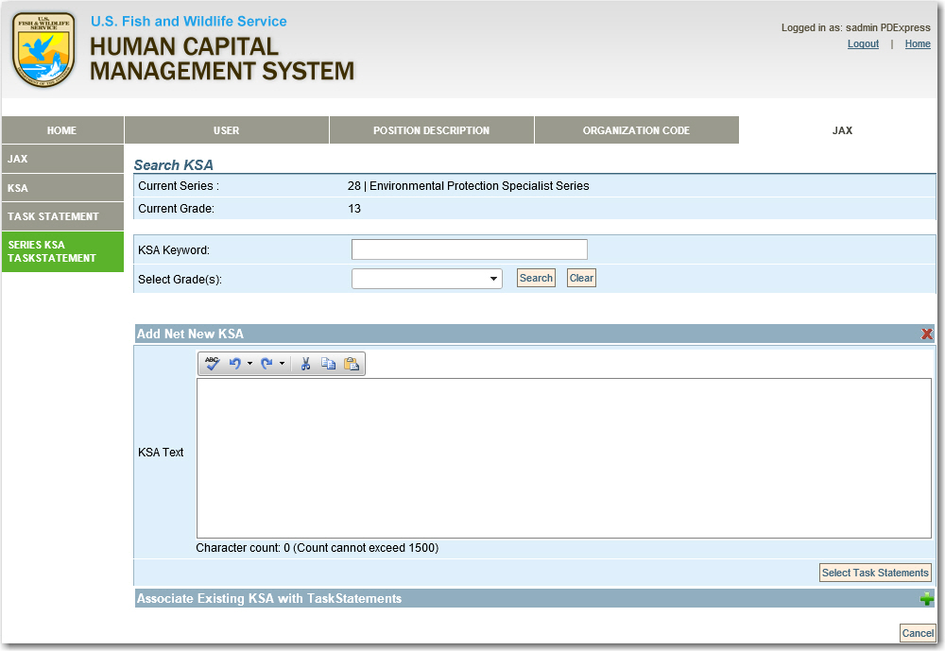

1. The Add Net New window expands to provide a text entry area into which the verbiage for the new KSA that will be added to the selected Series and Grade.
2. Once the verbiage is added, **click the Select Task Statements button**.
3. **Enter the Task Statement Keyword** to search for Task Statements to add to your KSA.
4. **Click on the ALL TASKS FOR CURRENT SERIES radio button** (since there will be no existing Task Statements for the net new KSA that you have added).
5. **Select the Grade and click SEARCH.**
6. A listing of Task Statements that meet your search criteria will appear.
7. **Click on the SELECT TO ADD radio box** to the left of each Task Statement that you wish to add.

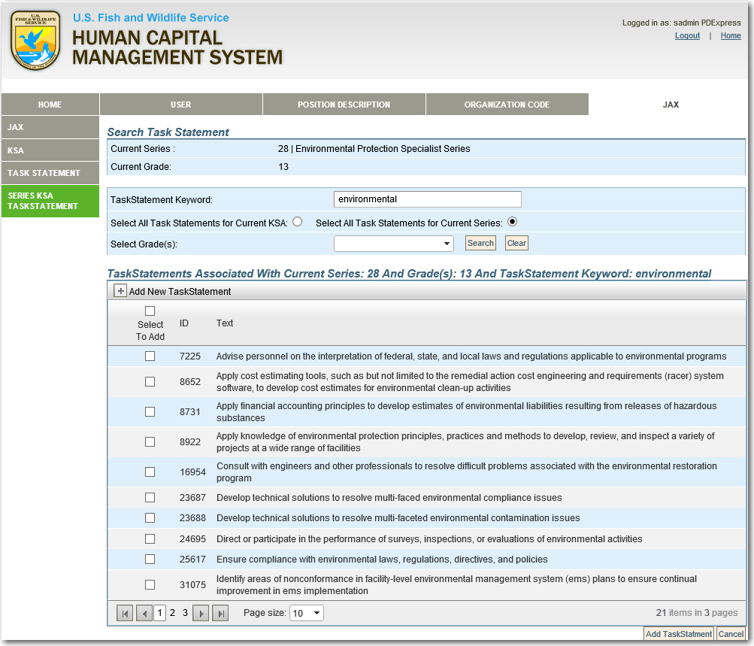

1. **Click the ADD Task Statements button** to add the Task Statements to your net new KSA.

# JAX Issue Tracker

To centralize and manage user requests for Regional and System Admins, HCMS includes a link to the **Support Desk**. This tool allows users to log requests for administrative activities. Administrators’ access to requests is dependent upon Admin Type and Region to which they are assigned.

The issue tracker functions exactly as it did for PD Express, with the addition of JAX issues that can be logged as well, to make the Issue Tracker relevant to the entire HCMS System.



##### APPENDIX: ACTIVITY SHEETS

ACTIVITIES for HM, HR, and ADMIN

## ACTIVITY 1: LOGIN to JAX and Explore the Navigation (page 13)

1. Access the JAX Training Site at <http://hcms.fws.doi.net/training>
2. Click Enter
3. Read the Notice and Click ACCEPT
4. Enter your FWS Active Directory Username and Password.
5. Click OK.
6. Click on the JAX Tab
7. Click ENTER
8. Click ABOUT and then browse the links presented there.
9. Click MENU and browse the links presented there.

## ACTIVITY 2: Interpret the MY TRACKER Dashboard (page 16)

1. Review the attached MY TRACKER DASHBOARD graphic.

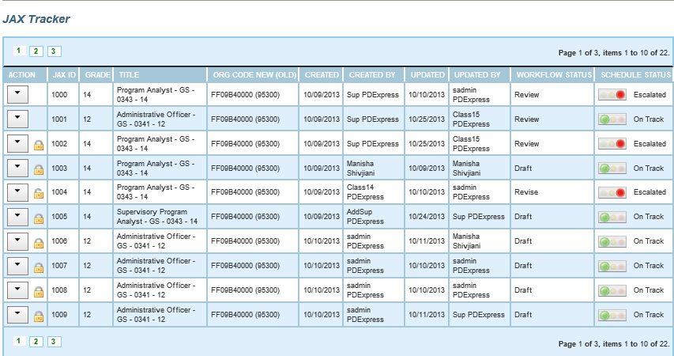

1. Complete the following questions:
   1. Which JA IDs are locked? \_\_\_\_\_\_\_\_\_\_\_\_\_\_
   2. Which JA IDs are in FINAL REVIEW? \_\_\_\_\_\_\_\_\_\_\_\_\_\_
   3. Are there any JAs that have escalated? \_\_\_\_\_\_\_\_\_\_\_
   4. If any JAs have been escalated, which ones are they? \_\_\_\_\_\_\_\_\_\_\_\_\_\_\_
2. When you have finished, compare your answers to the Answer Key on page 83

## ACTIVITY 3: Perform a Keyword Search in JAX (page 19)

1. Click MENU
2. Select SEARCH
3. On the Basic Search screen, select the JAX ID radio button.
4. Type 1010 in the Keyword Entry box.
5. Click SEARCH

## ACTIVITY 4: Initiate a New Job Announcement (page 24)

1. Click MENU
2. Select CREATE
3. Select the radio button beside Create New Job Announcement
4. Click SUBMIT

## ACTIVITY 5: Complete the Job Analysis/Position Information Screen (page 26)

1. Choose Pay Plan GS
2. Choose your Series
3. Choose your Org Code
4. Choose your Grade
5. Select your PD from the drop-down (Note: Contact your Regional HR Office if your PD is not in the PD Express so that it can be added.)
6. Select DEU
7. Click SAVE AND CONTINUE

## ACTIVITY 6: Complete the Job Analysis/ Duty KSA Screen (page 30)

1. Click the EDIT icon to edit the existing duty..
2. Copy part of the existing duty text and cut it from the screen (CTRL+C then CTRL+X)
3. Change time to 50%.
4. Click SAVE.
5. Click ADD NEW DUTY.
6. Paste your copied text (CTRL +Y)
7. Change time to 50%.
8. Click ADD DUTY/KSA.
9. Choose the “From Existing Library Radio button.
10. Choose the second KSA from the dropdown list.
11. Select KNOWLEDGE as the Qualification Type.
12. Select KSA-Quality Ranking Factor as the KSA Type.
13. Click ADD KSA.
14. Click CONITNUE.

## ACTIVITY 7: Complete the Job Analysis / Final KSA Screen (page 31)

1. Define your KSA as VERY IMPORTANT.
2. Select MUST BE ACQUIRED WITHIN 4-6MONTHS for your KSA.
3. Select VERY VALUABLE.
4. Click the IS FINAL checkbox.
5. Click CONTINUE.

## ACTIVITY 8: Complete the Job Questionnaire / KSA Screen (page 33)

1. Click the EDIT icon beside your KSA.
2. Click ADD NEW TASK STATEMENT.
3. Click the Search All Grades checkbox.
4. Choose the last statement from the list.
5. Click SAVE TASK STATEMENT.
6. Add two more task statements following the steps above.
7. Click CONTINUE.

## ACTIVITY 9: Complete the Job Questionnaire / Final Screen (page 34)

1. Click Preview Report, and then VIEW the pdf report.
2. Close the report.
3. Click Continue

## Activity 10: Complete the Category Ratings Screen (page 36)

1. Write one Category Rating statement for each KSA for BEST QUALIFIED.
2. Click the REMOVE WELL QUALIFIED button.
3. Review the QUALIFIED statements
4. Click SAVE.
5. Click SPELL CHECK.
6. Correct any misspellings.
7. Click SAVE and UNLOCK

## Activity 11: Start a New Job Announcement Based on an Existing Package (page 39)

1. Click MENU.
2. Click CREATE
3. Choose the Create Job Announcement from Existing radio button.
4. Click SUBMIT.
5. Enter the ID of the existing package.
6. Click SEARCH
7. Click the ACTION dropdown.
8. Choose COPY AND START NEW

**Activity 2 Answer Key:**

* 1. Which JA IDs are locked? \_\_1002,1003,1005,1006,1007,1008,1009\_\_\_\_\_\_\_\_
  2. Which JA IDs are in FINAL REVIEW? \_\_\_None\_\_\_\_\_\_\_\_\_\_\_
  3. Are there any JAs that have escalated? \_\_Yes\_\_\_\_\_\_\_\_\_
  4. If any JAs have been escalated, which ones are they? \_1000,1002,1004\_\_\_\_\_\_